UNIVERSITY OF MELBOURNCE

COMP90019 RESEARCH PROJECT

25 CREDITS

The Feasibility of De-identification on Clinical Narrative

Based on External Dictionary

*Author: Supervisor:*

Ao Li Karin Verspoor

*A thesis submitted in fulfilment of the requirements*

*for the degree of Master of Information Technology*

Student ID: 798657

Department of Computing and Information System

May 30, 2018

**Abstract**

**Key words:** De-identification Tool; External Dictionary; Clinical Text; Pattern Match; Machine Learning

Declaration

I certify that

- this thesis does not incorporate without acknowledgement any material previously submitted for a degree or diploma in any university; and that to the best of my knowledge and belief it does not contain any material previously published or written by another person where due reference is not made in the text.

- where necessary I have received clearance for this research from the University’s Ethics Committee and have submitted all required data to the Department.

- the thesis is _____ words in length (excluding text in images, table, bibliographies and appendices).

Acknowledgements

Thanks to my kindly supervisor Professor Karin Verspoor for her professional assistance, insightful guidance and patient support through my project. She offers the great help to me when I meet some challenges.

Thanks to my dear parents for their fully understand which keeps me positive.

Thanks to my lovely friends for their encouragement which makes me strong.

Table of Contents

List of Figures 5

List of Tables 6

1 Introduction 7

1.1 Background 7

1.1.1 Necessity of Clinical Narrative 7

1.1.2 Problem with Clinical Narratives 7

1.1.3. Necessity of De-identification Approach 8

1.1.4 Problem with De-identification Approach 8

1.2 Project Target 9

2 Project Description 11

2.1 Project Environment Settings 11

2.1.1 Data Corpora 11

2.1.2 Evaluation Methodology 12

2.2 De-identification Approach Description 15

2.2.1 Modified De-identification Approach 15

2.2.2 Colander Approach 17

2.3 De-Identification Tools Description 18

2.3.1 HMS Scrubber (HMS) 18

2.3.2 De-ID Scrubber (De-ID) 20

2.3.3 PHI-Reducer 21

2.3.4 MITRE Identification Scrubber Toolkit (MIST) 23

3 Performance Analysis 27

3.1 Modified De-identification Approach Analysis 27

3.1.1 External Dictionary Performance Analysis 27

3.1.2 Different Dictionary Performance Comparison 32

3.1.3 Variation of De-identification Tool 36

3.2 Colander Approach Analysis 42

4 Conclusion 43

Reference 44

Appendix 45

# List of Figures

Figure 1. Effect of De-identification 8

Figure 2. Some problems with current scrubbed tools 9

Figure 3. Original training dataset 11

Figure 4. Different kind of definitions of Recall in this project 13

Figure 5. Different kind of definitions of Precision in this project 14

Figure 6. Split original dataset into different size 15

Figure 7. Train the dictionary 16

Figure 8. An example of 'Position' dictionary 16

Figure 9. The header of XML format in HMS 19

Figure 10. RegExp for detecting doctor name 20

Figure 11. Library for people and hospital names 20

Figure 12. The de-identification effect on HMS 21

Figure 13. The fixed structure in De-ID 21

Figure 14. An example of the default dictionary in De-ID 22

Figure 15. The de-identification effect on De-ID 22

Figure 16. An example of RegExp for salutation 23

Figure 17. Date RegExp in PHI-Reducer 24

Figure 18. Address indicator in PHI-Reducer 24

Figure 19. An example of splitting the file 25

Figure 20. The effect of the reformatting in MIST 26

Figure 21. Basic steps for de-identification in MIST 27

Figure 22. The comparison of Precision and Recall 30

Figure 23. The comparison of Precision and Recall 32

Figure 24. The comparison of Precision and Recall on 34

Figure 25. The comparison of Precision and Recall on 36

Figure 26. The comparison between HMS and De-ID on 'Only_Import_Total' 42

# List of Tables

Table 1. Original De-ID and improved De-ID 38

Table 2. Original De-ID and Improved De-ID 39

Table 3. Only use training dictionary on HMS and De-ID 41

# 1 Introduction

In this chapter, the background about the necessity and current exist problem with clinical narratives and de-identification approach will be illustrated in turn. Then, the improvement direction of de-identification approach in this project will be briefly described.

## 1.1 Background

### 1.1.1 Necessity of Clinical Narrative

A clinical narrative, as its literal meaning, is a first person “story” written by a clinician that each of it can describe a specific clinical event or situation for a particular patient. Obviously, Clinical narrative plays an important role in clinical decision making [1]. The value of writing the narrative clinicians are that it allows clinicians to not only explain and shared them diagnose with their patients, but also practice current clinical with their professional colleagues. In addition, the narrative can encourage clinicians more deeply analyse and reflect on their clinical practice so that give them more insight for diagnosing [2].

### 1.1.2 Problem with Clinical Narratives

However, these clinical texts contain a large amount of patient privacy information, such as name, address, phone number etc., which let patients’ personal confidentiality on the line. Also, with the development of *Electronic Health Records* *(EHR)* system, a large number of patients’ data nowadays can be readily accessed and provided through clinical text for several various background people [3]. Furthermore, the *Health Insurance Portability and Accountability Act (HIPAA)* explains that people or authorities need to get patients’ consent and the approval of the *Internal Review Broad* *(IRB)* before making use of their clinical texts, but lacking controls of all aspects make these requirements implacably in practice.

### 1.1.3. Necessity of De-identification Approach

Thus, for the sake of solving the problem of leaking out patients’ confidential information from the clinical narratives, de-identification approaches appear. In general, de-identification approach is such a kind of method to identify and remove patients’ privacy data, called as *Protected Hospital Identifier (PHI)* defined by *HIPAA* [3]*,* from the clinical texts so as to protect their personal details. An example of de-identification effect on *MIST Scrubber Toolkit* is shown as *Figure.1*. [5].



original clinical text

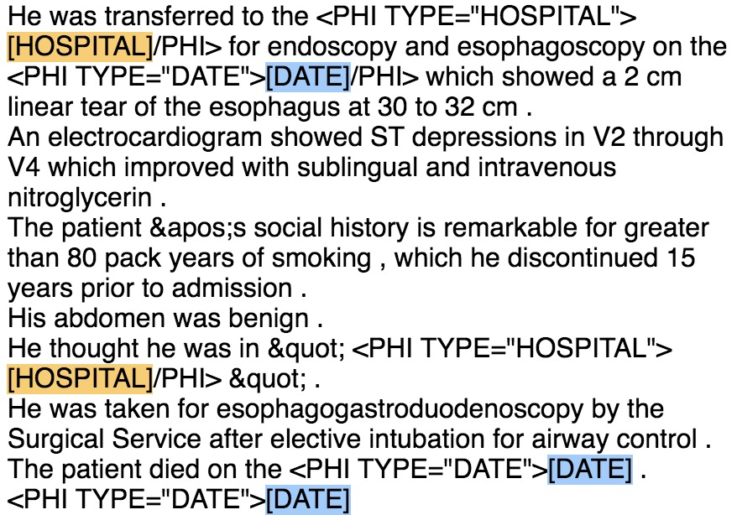

*scrubbed clinical text*

Figure 1. Effect of De-identification

### 1.1.4 Problem with De-identification Approach

From *Figure.1*., the effect of current existing de-identification process seems perfect, but there are still many problems with current exist de-identification tools. Three major de-identification problems are ‘under de-identification problem’, ‘wrong de-identification problem’ and ‘over de-identification problem’. Before introducing each of problem in detail, some basic steps for the following examples to de-identify *PHI* tokens should be introduced firstly. The example tool below will firstly automatically divide original text into different regions, shown as the grey frame in *Figure.2*. Then it will try to recognize and tag *PHI* tokens for different *PHI* categories in various colours. Finally, replace the recognized part with the specified replacer.

* ***Under de-identification problem*** means some of the *PHIs* are not recognized by the tool. For example, “Doctor Stable” cannot be recognized in *Figure.2. (i)*
* ***Wrong de-identification problem*** is that some of the *PHIs* can be recognized but in a wrong category. As shown in *Figure.2. (ii),* phone number is wrong regarded as ID.
* ***Over de-identification problem*** is an opposite way comparing to the under de-identification problem*,* which recognize some plain clinical texts as target *PHI* tags but actually they are not. *Figure.2. (iii)* describes one of the situations that the plain text *‘CARCINOMA’* is recognized and tagged as *‘DOCTOR’* category.

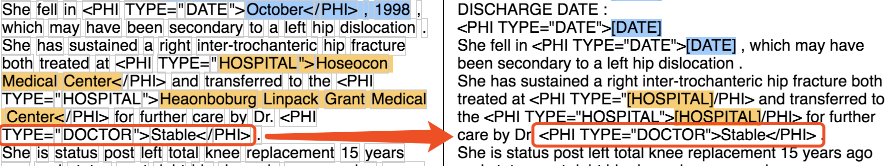

*(i) Under De-identification Example*

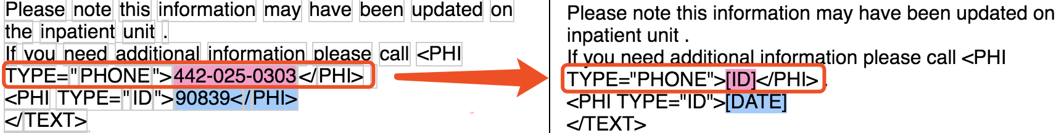

*(ii) Wrong De-identification Example*

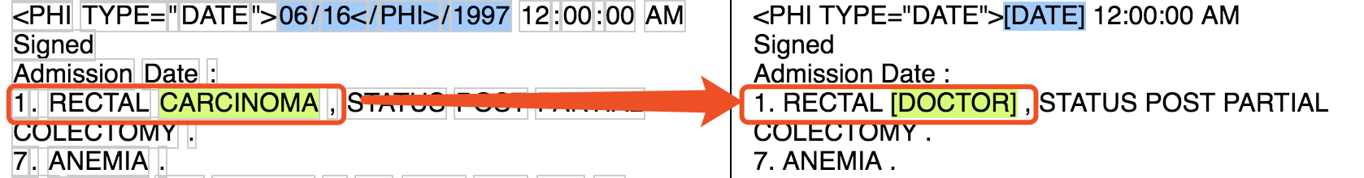

*(iii) Over De-identification Example*

Figure 2. Some problems with current scrubbed tools

## 1.2 Project Target

In this report, the main purpose of the project is to evaluate the performance of various exist de-identification tools.

The first part puts forward a suppose that whether to use an external dictionary that is trained from the training dataset can help the performance of the de-identification. The dataset the project used has multiple distinct *PHI* categories and some of them are not applicable in some de-identification tools, so the number and type of *PHI* categories used in this project are narrowed down. In addition, it will focus on analysing ‘*Location*’, *‘Hospital’*, *‘Doctor’* and ‘*Patient*’ four *PHI* categories and some parts will combine *‘Location’ and ‘Hospital’ as ‘Position’* category and *‘Doctor’ and ‘Patient’ as ‘People’* category. More specific explanation of these two methods will be depicted in Section 2.

Also, in Section 2, an opposite approach, which is called ‘*Colander Approach’* in this project, will be also introduced as the second part. It is such a process that only keep the terms that are wanted in the clinical narratives, meaning that it considers all other terms as *PHIs* and then try to get rid of them. And the analyses are based on the same class of *PHI* categories as mention in the previous paragraph.

*Recall* and *Precision* will be considered as the measurements for the performance analysis in this project. The definition and illustration of both will be depicted in Section 2 in detail. And the results of the *Recall and Precision* on different de-identification tools will be shown in Section 3.

Conclusion and the direction of future development will be provided in Section 4, which will not only summarise the overall work in this project but also give an overview of a direction of future development based on the de-identification tools.

For the sake of giving more insights, all of the complete experiment data analysed in Section 3 will be attached on the *APPENDIX*.

# 2 Project Description

In this section, a comprehensive description of project environment settings and two types of de-identification approach will be introduced. Besides, four scrubber tools used in this project for de-identification will also be detailed illustrated.

## 2.1 Project Environment Settings

### 2.1.1 Data Corpora

Various *EHR* systems have provided distinct framework of clinical narrative and they are generally unstructured [2], so it is crucial to select one specific data corpora for the experiment. In this project, dataset from the *Informatics Biology and the Bedside (i2b2)* organization will be used for experiment and analysis. Reasons for choosing i2b2 data are that:

1. It is such a popular dataset in biomedical computing and has an increasing used for gaining insights to improve healthcare [6].
2. I2b2 dataset has provided sets of clinical notes from the *Research Patient Data Repository* at *Partners HealthCare* [7]. And *PHI* terms have already tagged on those notes.
3. Multiple medical de-identification tools are supported to process on it. For example, some de-identification tools used in this project have particular commands for processing i2b2 data rather than the other datasets [5].

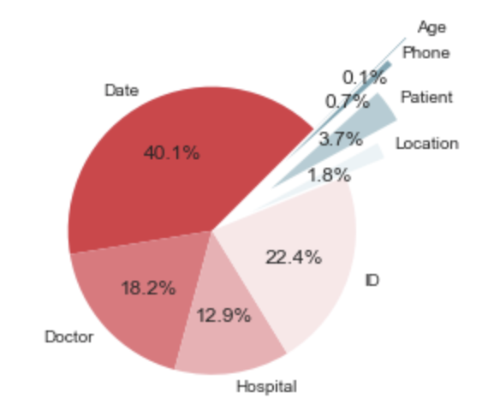

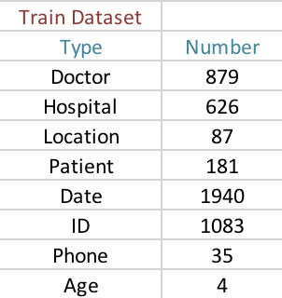

Figure 3. Original training dataset

More verbose, i2b2 annotated data corpora used in this project contains 201 clinical records, which consists 4835 *PHI* instances from 8 *PHI* categories as described in *Figure.3.* There are 8 classes of *PHIs*, but only *‘Doctor’, ‘Hospital’, ‘Location’ and ‘Patient’* categories are used in this project. Because those categories have adequate number of *PHIs* and they are much more meaningful than others on analysis.

However, because of small size and uneven distribution of the dataset, some parts of the analysis will combine ‘*Doctor’* and ‘*Patient’* categoriestogether *as* an integrated category, called*‘People’ category.* Similarly, *‘Location’ and ‘Hospital’ will be gathered and considered as* a *‘Position’ category.*

### 2.1.2 Evaluation Methodology

For the sake of analysing the performance of distinct de-identification toolkits, *Recall* and *Precision* are considered as the evaluation methodology and both of them are desirable to be high in the experiment. Especially, High *Recall* is much more preferred than high *Precision* in this project. Because the purpose of the project is to remove privacy information, it tends to remove as many potential *PHI* terms as possible and not quite matter if those are really real *PHI* tokens. Therefore, *Precision* would be taken as the second priority in the project.

Importantly, as mentioned above, not all of the *PHI* terms are used in this project, so not all *PHI* terms in using dataset are grouped together but rather by their type when calculating *Recall and Precision*. For instance, all of the *‘Doctor’, ‘Patient’, ‘Hospital’ and ‘Location’* *PHI* terms will be grouped together in Section 3.1, because a holistic de-identification analysis based on these four categories will be illustrated in that section. However, it will only need to be integrated *‘Doctor’* and *‘Patient’* terms together or *‘Hospital’ and ‘Location’* terms together, as a ‘*People’ and a ‘Position’* analyses respectively instead in Section 3.2. Thus, the definition of *Recall and Precision* are different in different sections, which will be introduced as the following subsection.

#### 2.1.2.1 Recall

Generally, the definition of *Recall* is the fraction of relevant instances that have been found over the total amount of relevant instances. In other words, it is the number of true positive over the total number of terms that actually belong to the positive class. Take the project experiment data into, it becomes the number of correct scrubbed terms on all *PHI* categories divided by the total number of all tagged *PHI* terms in the original text, which means the proportion of correct de-identified *PHI* terms in all of the PHI terms. Thus, the definition of *Recall* in general analysis can be taken as *Figure.4*. *(i).* However, it has another three variations for distinct analysis purposes in this project as shown in *Figure.4. (ii), (iii) and (iv) respectively.*

Figure 4. Different kind of definitions of Recall in this project

$$Recall= \frac{\# Correct Scrubbed Terms on All PHI Category}{\# Tagged Terms on All PHI Category}$$

*(i) Definition of Recall in general analysis*

$$Recall= \frac{\# Correct Scrubbed Terms on 'D, P, L, H^{'} PHI Category}{\# Tagged Terms on 'D, P, L, H^{'} PHI Category}$$

*(ii) Definition of Recall in holistic analysis (Section 3.1 & 3.3)*

$$Recall= \frac{\# Correct Scrubbed Terms on 'D, P' PHI Category}{\# Tagged Terms on 'D, P' PHI Category}$$

*(iii) Definition of Recall in ‘People’ analysis (Section 3.2 & 3.3)*

$$Recall= \frac{\# Correct Scrubbed Terms on 'L, H' PHI Category}{\# Tagged Terms on 'L, H' PHI Category}$$

*(iv) Definition of Recall in ‘Position’ analysis (Section 3.2 & 3.3)*

*Note: ‘D’ – Doctor, ‘P’ – Patient, ‘L’ – Location, ‘H’ – Hospital*

#### 2.1.2.2 Precision

The general definition of *Precision* is the fraction of relevant instances among all of the retrieved instance. Namely, the *Precision* for a category is the number of true positives over the total number of terms labelled as belonging to the positive class. As for this project, the definition of general *Precision* is the number of correct scrubbed terms on all *PHI* categories divided by all scrubbed terms on all *PHI* categories (as shown in *Figure.5. (i)*), meaning the proportion of correct de-identification terms within all of the scrubbed terms. Additionally, similar to the definition of *Recall*, there are three variations definition of *Precision* in this project, which is shown separately as *Figure.5. (ii), (iii) and (iv).* They are following the principle of the general definition, but obviously for different purposes.

$$Precision= \frac{\# Correct Scrubbed Terms on All PHI Category}{\# Scrubbed Terms on All PHI Category}$$

*(i) Definition of Precision in general analysis*

$$Precision= \frac{\# Correct Scrubbed Terms on 'D, P, L, H^{'} PHI Category}{\# Scrubbed Terms on 'D, P, L, H^{'} PHI Category}$$

*(ii) Definition of Precision in holistic analysis (Section 3.1)*

$$Precision= \frac{\# Correct Scrubbed Terms on 'D, P' PHI Category}{\# Scrubbed Terms on 'D, P' PHI Category}$$

*(iii) Definition of Precision in ‘People’ analysis (Section 3.2)*

$$Precision= \frac{\# Correct Scrubbed Terms on 'L, H' PHI Category}{\# Scrubbed Terms on 'L, H' PHI Category}$$

*(iv) Definition of Precision in ‘Position’ analysis (Section 3.2)*

Figure 5. Different kind of definitions of Precision in this project

*Note: ‘D’**– Doctor, ‘P’ – Patient, ‘L’ – Location, ‘H’ – Hospital*

## 2.2 De-identification Approach Description

There are two main types of method implemented in this project. The first one is to modify the general de-identification approach by using external dictionaries that are trained from the project data corpora. Then, in the second part, called *Colander* approach, is a relative opposite way of de-identification that will only contains the terms that are needed. The following two sub-section will describe these means in detail.

### 2.2.1 Modified De-identification Approach

In this part, a concept of training dictionary will be introduced as a way to modify the general de-identification approach. The steps of the modified de-identification method are as below:

1. Split original dataset into training part and test part:

Randomly select 90%, 80%, 70%, 60% and 50% from the original dataset as the training set respectively (*Figure.6.)* and the rest of the original dataset will be taken as the test dataset.

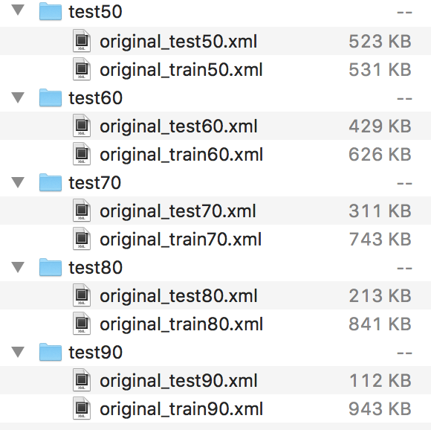

Figure 6. Split original dataset into different size

1. Use the training part to train the external dictionary:

Some of the scrubber tools do not differentiate ‘*Doctor’* and *‘Patient’* name or ‘*Location’* and *‘Hospital’* position, so combine *‘Doctor’* and *‘Patient’* categories as *‘People’* and *‘Location’* and *‘Hospital’* categories as ’*Position*’ in this project when training specified dictionary. The processes of training the external dictionary are in a simple way, which just retrieves some tagged *PHI* terms for some particular categories. Take the *‘Position’* dictionary as an example, it is created by retrieving and collecting *‘Hospital’* and *‘Location’* *PHI* tags from training dataset. A simple collecting example in the training dictionary process is as *Figure.7.*

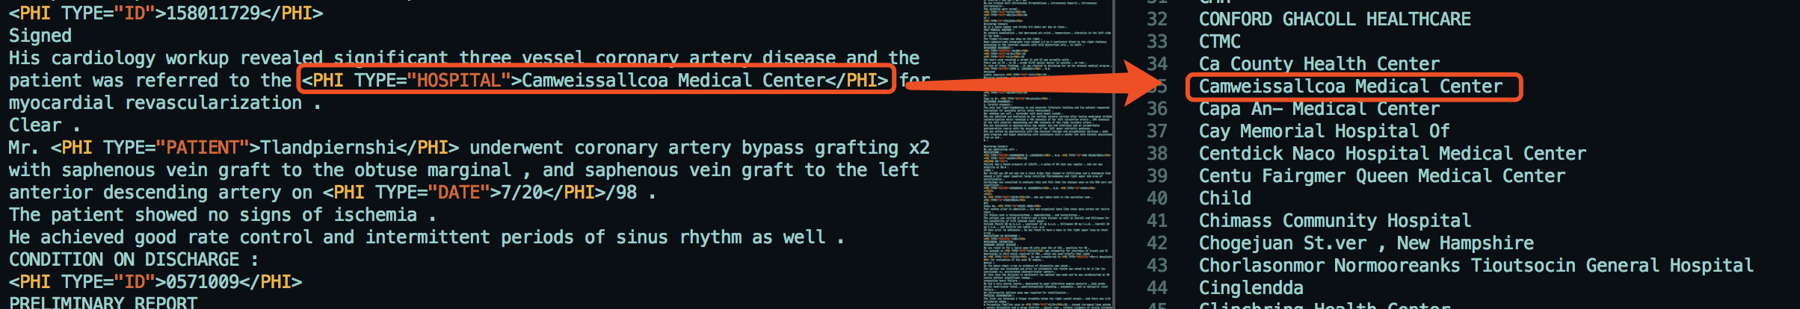

Figure 7. Train the dictionary

After collecting all of the *‘Hospital’ and ‘Location’ PHI* tokens in the training dataset, a sorting and de-duplicating processes are run on the file that is stored all of the collecting *PHI* terms. The file after sorting and de-duplicating will be regarded as a *‘Position’* external dictionary and looked like *Figure.8*. Because the external dictionary is decided by the training dataset, there might be multiple various of *‘Position’* dictionaries that are generated by different training dataset.

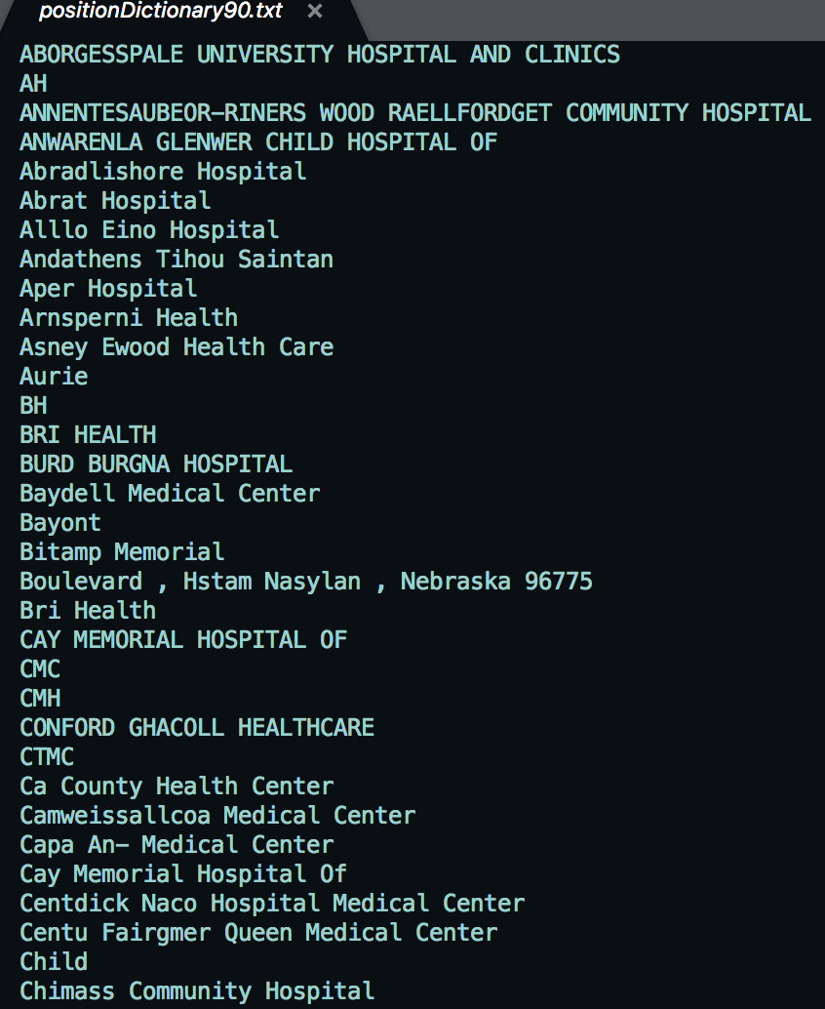

Figure 8. An example of 'Position' dictionary

1. Import the dictionary into the scrubber tools

All of the scrubber tools used in this project for de-identification are based on two different principles ---- ‘*Pattern Matching Based’* and ‘*Machine Learning Based’*, so there are two distinct ways of using the external dictionary files.

Firstly, to the pattern matching based scrubbers, dictionary file can be imported into and used directly as a matching file. What makes it work is basically because this kind of scrubbers are capable of comparing the stored *PHI* tokens from the dictionary files to all of the terms in the test dataset.

However, to the machine learning based de-identification tools, dictionary file now cannot be applied straightforward like pattern matching based scrubbers, because this kind of tools would like to learn *PHI*s’ features itself by using machine learning algorithms. Thus, the original training datasets will be offered to the machine learning based tools instead of the learned external dictionaries.

1. Test the performance on the test part of the dataset:

From now on, the de-identification tools can be used to scrub on the test dataset. The specification about using each of the scrubbers used in this project will be illustrated in Section 2.3. Moreover, in Section 3, the personal performance for each of the scrubbers and the comparison of de-identification effect among them will be specially described.

### 2.2.2 Colander Approach

## 2.3 De-Identification Tools Description

In this part, four various scrubber tools that are used in this project for scrubbing the clinical narratives will be introduced in detail. They are the *HMS Scrubber, De-ID Scrubber, PHI-Reducer and MITRE Scrubber Toolkit (MIST).* As mentioned before, there are two kinds of principle for scrubbing.The first three of them are based on pattern matching principle and the last one is on the strength of machine learning based method. The purpose for choosing these tools are that, 1) All of them are supported to process on i2b2 data format. And 2) They are free, open source and easy to modify and improve. More detailed description of these tools is as below.

### 2.3.1 HMS Scrubber (HMS)

*HMS Scrubber* is a *HIPAA* compliant and de-identification tool tailored for pathology reports [3]. In order to remove tagged *PHIs, HMS* has three steps to do the de-identification [8], which are basically as following:

1. Pre-process and convert the clinical text into a specific XML format, which includes a header and a body portion of the clinical report. An example of the header section of the XML format is shown in *Figure.9*.

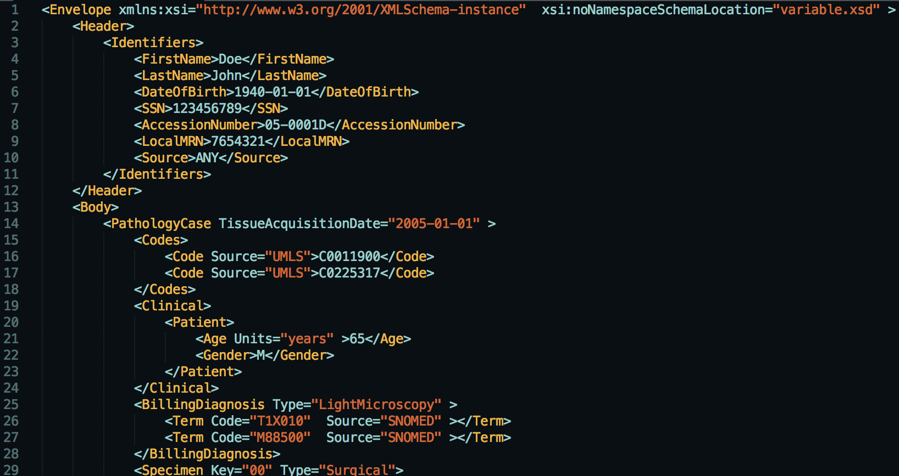

Figure 9. The header of XML format in HMS

1. Use regular expressions (*RegExp*) and libraries for identificating potential *PHI* terms. There are about 50 *RegExp*s built in the scrubber library. Additionally, popular suffixes and prefixes that are likely to stand for names (e.g. Dr., Mr. … etc.) are applied in this step for detecting. Take *‘Doctor’ PHI* category as an example, *HMS* has many very detailed *RegExp*s for detecting potential doctor’s name pattern, like in *Figure.10.*

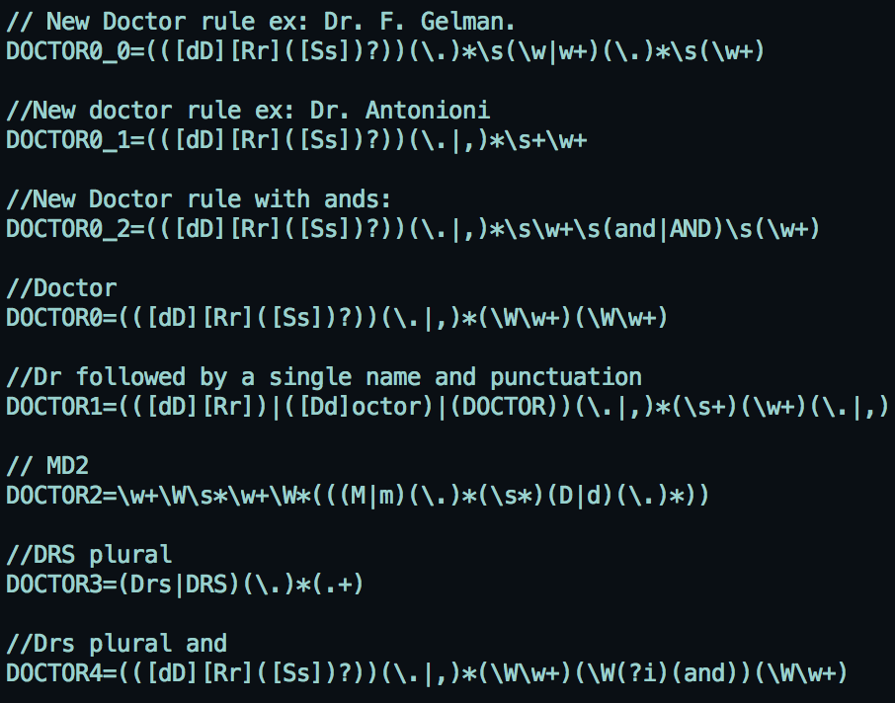

Figure 10. RegExp for detecting doctor name

Besides, there are two sorts of name libraries in this method that are about person and hospital. Because these libraries are allowed to be augmented, the external dictionary generated from this project can be imported into library in this step. Part of exist name libraries in *HMS* are depicted in *Figure.11.*

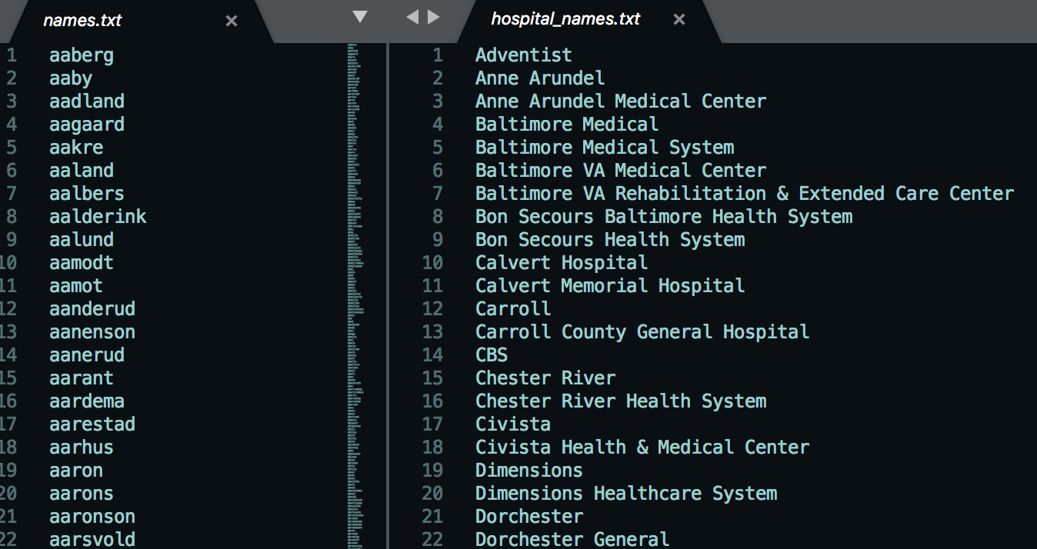

Figure 11. Library for people and hospital names

1. Replace all of the recognized words with a series of category tags.

The comparison of the original text and the output scrubbed text from *HMS* is as *Figure.12.*



Figure 12. The de-identification effect on HMS

### 2.3.2 De-ID Scrubber (De-ID)

*De-ID Scrubber* is a commercial tool created and developed at the *University of Pittsburgh* [9]. It also uses pattern matching algorithms with the help of dictionaries to recognize *PHI* terms. The basic steps for de-identification in *De-ID* is very similar to *HMS*. However, the major distinction between *HMS* and *De-ID* is the default number and size of the dictionaries --- *De-ID* has a more comprehensive dictionary library rather than *HMS*. The basic process of *De-ID* method is as following:

1. Pre-process and reformat original clinical narratives into a fixed structure (*Figure.13*.). Obviously from diagram, texts that are imported into *De-ID* need to have a start, a body and an end section for each clinical record, so the original i2b2 clinical narratives are required to be transformed into this fixed structure firstly.

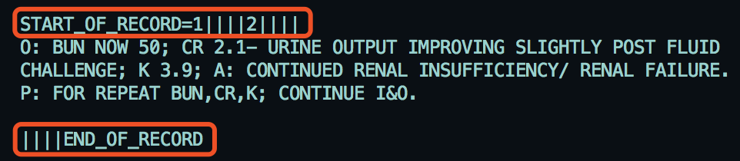

Figure 13. The fixed structure in De-ID

1. Use *RegExps* and dictionaries to detect *PHI* terms. As mentioned above, the number of the original dictionaries in *De-ID* libraries is much bigger than in *HMS*. For instance, there are many classifications of dictionaries about person’s and locations’ names. Part of the dictionary is shown in *Figure.14. (i).* Besides, it adopts the *UMLS Metathesaurus* to help in identifying medical words that should be kept with the text that are described in *Figure.14. (ii).* Obviously, the training dictionaries that are generated from the project training can import into the scrubber in this step.

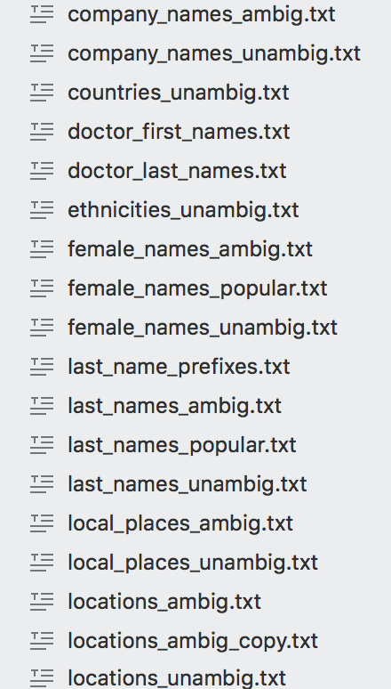 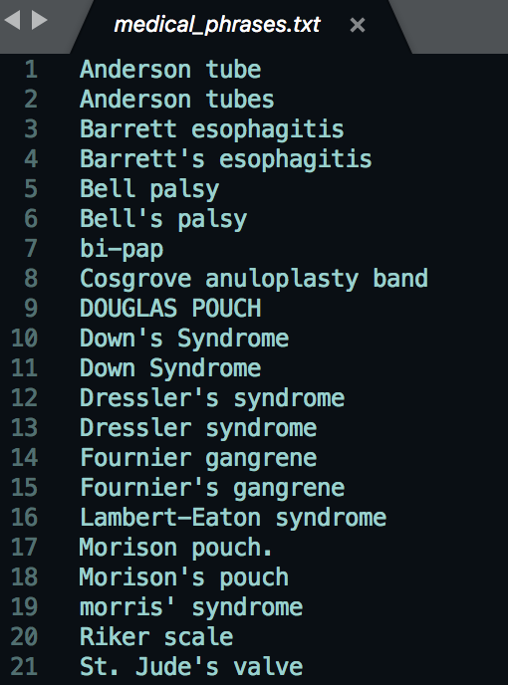

*(i) Comprehensive dictionary category (ii) Example of Metathesaurus*

Figure 14. An example of the default dictionary in De-ID

1. Replace all of the recognized words with a series of category tags.

The comparison of the original text and the output scrubbed text from *De-ID* is as *Figure.15.*

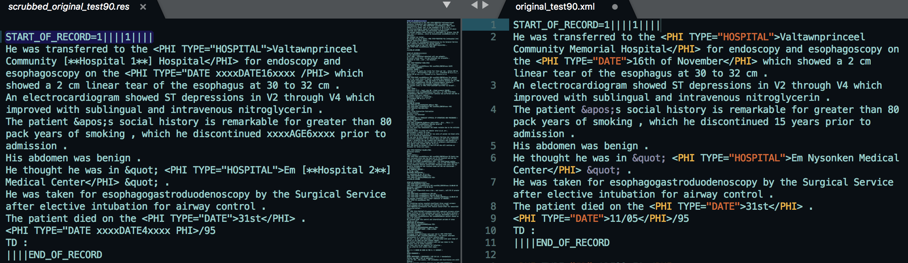

Figure 15. The de-identification effect on De-ID

### 2.3.3 PHI-Reducer

*PHI-Reducer* is also a pattern matching based de-identification tools. Compare it to the above two scrubbers, one major difference is that the detection processes in *PHI-Reducer* are in multiple levels --- document level, sentence level and word level. In other words, it will firstly process the text in a document level. Then separate the text into multiple sentences and identify *PHIs* in a sentence level. Then divide various sentences into different individual words and recognize PHI words in a word level. It tries to use various levels of recognition to scrub more *PHI* tokens. Moreover, *PHI-Reducer* is an application that makes use of the *Natural Language Toolkit (NLTK)* and the *SpaCy Packages*, so it covers two respects of identifying names by usingthese two packages separately. Also, what should be highlight is that *PHI Reducer* is such a toolkit that supports multi-processing, meaning that the de-identification processes can be run on multiple computers in parallel. On account of this advantage, it is likely to be more efficient than other scrubbers when the size of the processing dataset is large. However, there are not visible dictionary libraries used in this tool and it applies a large amount of *RegExps* and inline package libraries for identifying *PHI* terms instead. The scrubbing procedures are as below:

1. Use *RegExps* to search for salutations. Most of the salutations are represented by a ‘.’ symbol, so this process must be done before the document is separated into sentences, meaning that it is in a document level. An example of the *RegExp* for checking salutations is depicted in *Figure.16*.

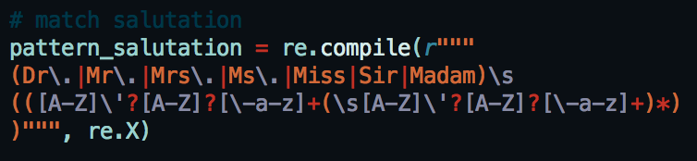

Figure 16. An example of RegExp for salutation

1. Split documents into sentences and use *RegExps* to identify *PHI* terms. In this level of *RegExp*, pattern will consider only one word at a time. For example, it will identify the word *‘email’, ‘DOB’, ‘postcode’* or any others containing 5 or more digits. External dictionary can be imported to the scrubber in this step. *Figure.17.* gives an example of the ‘*Date’ RegExp* used in *PHI-Reducer*.

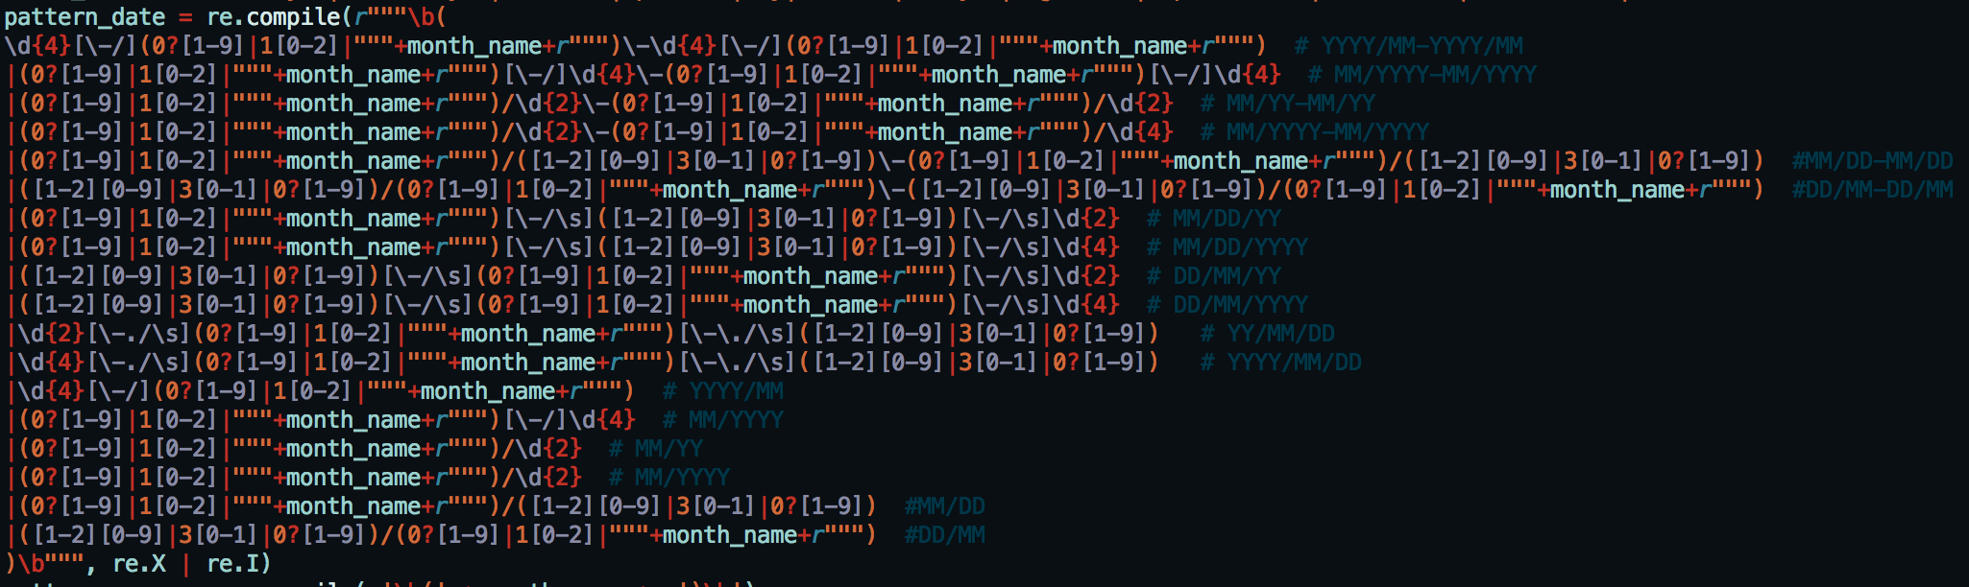

Figure 17. Date RegExp in PHI-Reducer

1. Split sentences into words and use *RegExps* to identify the context of *PHI* terms. For instance, check the preceding words *‘age’ or ‘years’* for *‘DOB’*. Another example is about the address, *PHI Reducer* regards an address is supposed to contain the following possible indicators in *Figure.18.,* so it is likely toidentify address by identify these key words.

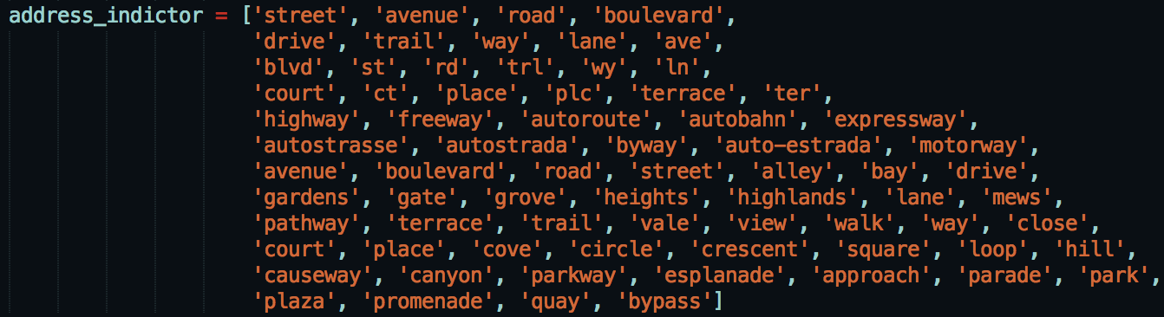

Figure 18. Address indicator in PHI-Reducer

1. Use both *NLTK* and *SpaCy* toolkits to label a term and see whether they get the same label. If so, identify the word as a *PHI* terms. If not, add this term into a whitelist as a protected word.
2. Scrub all of the words that are recognized as a *PHI* words.

### 2.3.4 MITRE Identification Scrubber Toolkit (MIST)

*MIST* is the only machine learning based scrubber used in this project, which makes use of the *Conditional Random Fields (CRF)* classifier for automatically learning *PHI*s’ features on the training clinical records so as to de-identify and protect patients’ sensitive information [10]. There are two different de-identification tasks inside the application that are the *AMIA* task and the *HIPAA* task. In this project, only *AMIA* task is used in the experiment. The main reason of ignoring *HIPAA* task is that there is not much difference between these two tasks. Fundamentally, the distinction between these two methods is that *AMIA* task contains eight annotation classes, but *HIPAA* consists 18 categories, whose annotations are more detailed than *AMIA* task. However, i2b2 data is used as dataset in this project and the categories of i2b2 dataset is the same as in the *AMIA* task, so the level of category in *AMIA* task is completely enough for i2b2 data. The general scrubbing process for *MIST* is as below:

1. Pre-process and reformat the training dataset. The original i2b2 data are not under appropriate format for *AMIA* task and there are two main reasons for that
2. The original i2b2 file is too large, but *MIST* can only process on small size of file. So, it is necessary to separate the original big file into various small portions and each portion becomes a new small file. Additionally, *MIST* can separate large file by identifying the i2b2 record IDin the context and splitting the file by it*,* so then each of the small file will be an independent clinical record. For instance, 640.xml, 641.xml …. etc. in *Figure.19.* means the clinical record 640, record 641 … etc. in original i2b2 training dataset respectively.

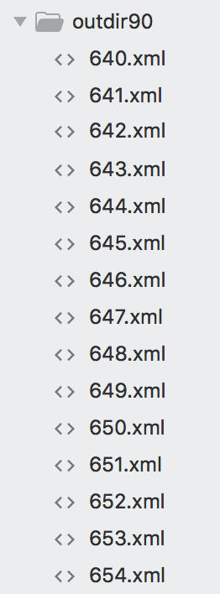

Figure 19. An example of splitting the file

1. The annotation style of i2b2 is *ENAMEX-style*, however, *AMIA* task need to run on *PII-style*. Therefore, need to reformat the annotations. The comparison between original i2b2 data and data after reformatting is shown in *Figure.20*.

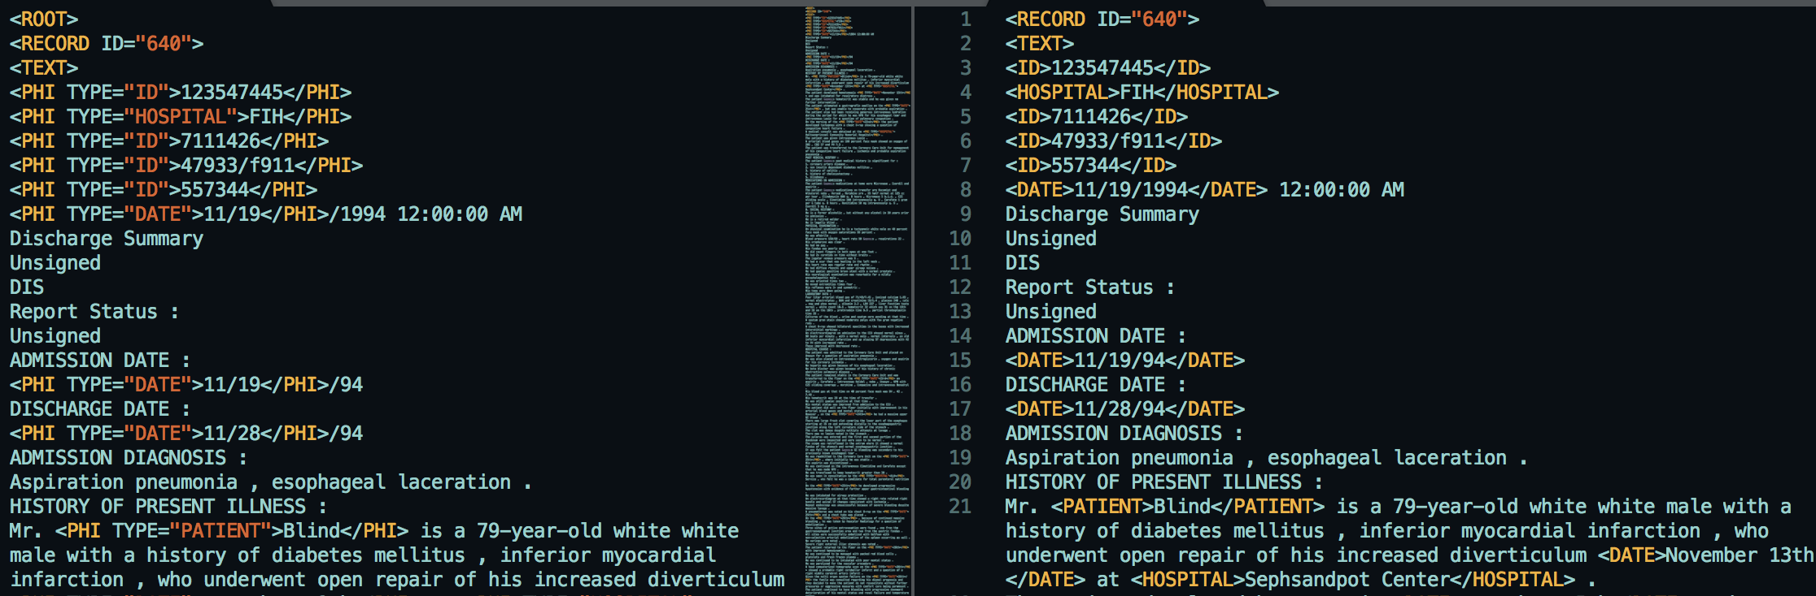

Figure 20. The effect of the reformatting in MIST

1. Use the reformatted files to train and build a model for de-identification. Because *MIST* is based on machine learning algorithms, implying that the external dictionaries cannot be imported into and used in *MIST* directly, reformatting raw files are needed to train the model straightforward instead of using the external dictionaries off the shelf.
2. Scrub the *PHI* terms by using the trained model. The key steps for processing de-identification are “zone, tag, nomination and transform”, which basically divide the original text into some small tokens first, then tag each token and replace the *PHI* words with a specified replacer. *Figure.21 has* a series of diagrams that briefly shows the scrubbing processes. Obviously, *MIST* firstly divides the original text into multiple small zones. Then try to analyse if *PHI* tokens exist in each of the small zones. And finally replace the recognised *PHIs* with the predefined replacer.

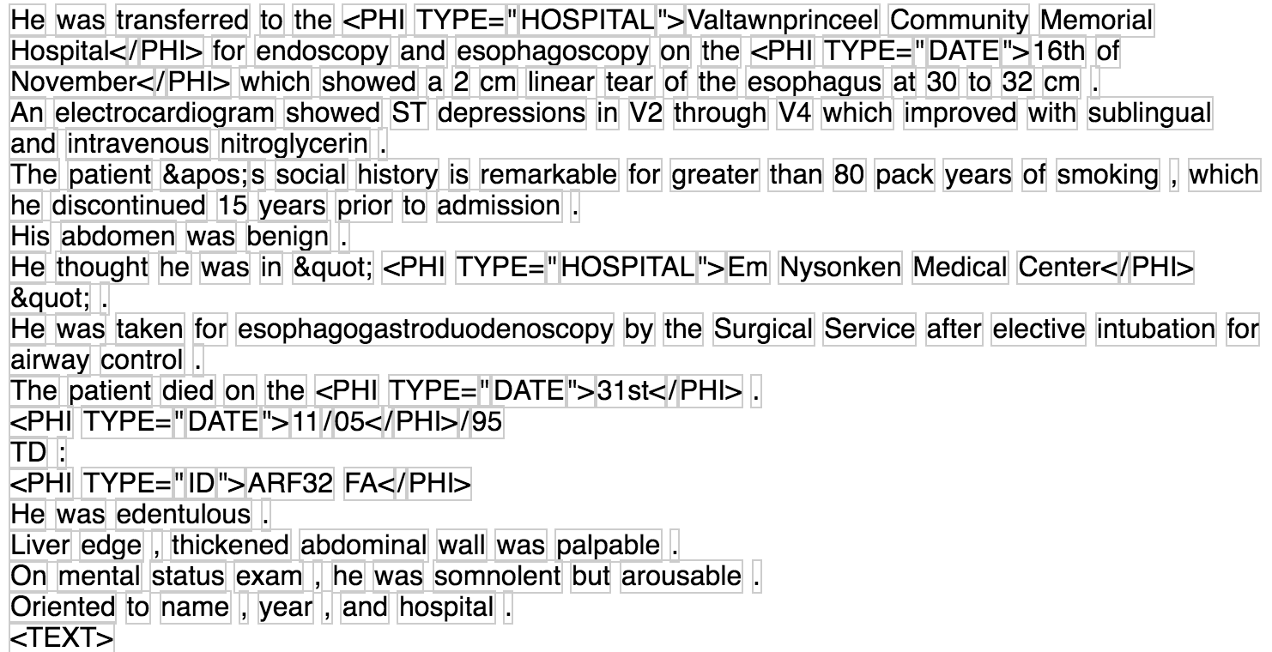

*(i) zone*

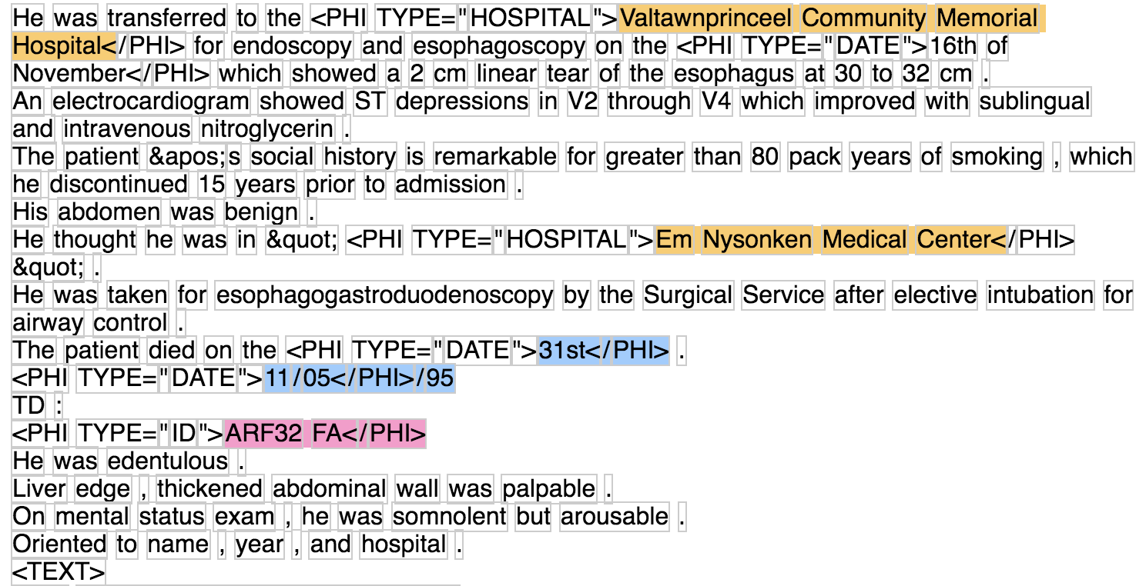

*(ii) tag*

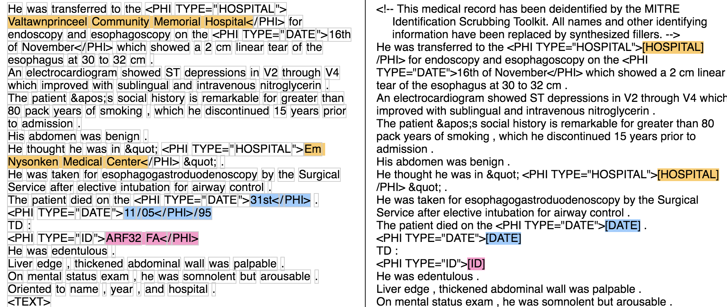

*(iii) nominate and transform*

Figure 21. Basic steps for de-identification in MIST

*Note:* ***zone:*** *find appropriate regions’ boundaries of the document to process.*

***tag:*** *add PII annotations.*

***nominate****: create replacement phrases for the regions of text tagged with PII annotation.*

***transform****: replace PII annotation with the replacer.*

# 3 Performance Analysis

In this section, some doubts and insights will be gained from observing the value of *Recall* and *Precision* in every experiment. Thus, a detailed performance analysis for the modified de-identification approach and colander approach will be presented.

## 3.1 Modified De-identification Approach Analysis

In order to assess the efficiency of the external dictionary, there are a series of analyses on various aspects that will be described as following:

* Firstly, the assessment will be generated from the comparison of performance on whether to import an external dictionary into the scrubber or not among four various de-identification tools. It will illustrate the effect of de-identification on distinct scrubbers.
* Then, the second part will compare different external dictionaries’ behaviours on various de-identification tools, which can show different sorts of external dictionaries’ capability on scrubbing.
* Finally, two ways of improvement will be applied on *De-ID and HMS* as a variation of scrubber. One variation is that a combination on *De-ID and HMS* will be generated to evaluate if it can obtain much better de-identification performance than only using one of them. And another aspect is to only use the training external dictionary respectively on *De-ID and HMS* to de-identify *PHIs*, which means that the default libraries and dictionaries used in original scrubbers will be removed and the scrubbing results are only related to the training external dictionaries.

### 3.1.1 External Dictionary Performance Analysis

An analysis of the performance of external dictionary is presented in this part. The external dictionary used in this section is such a hybrid dictionary, which contains *‘Doctor’* name, *‘Patient’* name, *‘Hospital’* position and patients’ *‘Location’* together. Because different scrubber has distinct de-identification ability on various *PHI* categories, the purpose of using this hybrid dictionary is to see the general de-identification performance on each de-identification tools. It is worth to noting that the original i2b2 dataset has already separated into 2 parts --- training dataset and testing dataset. And the experiment in this report will generate five different sizes of training dataset, whose size are 90%, 80%, 70%, 60% and 50% respectively from original i2b2 dataset. In this way, the number of the clinical records needed for training can be inferred from the de-identification performance. In other words, an approximate minimize size of training dataset needed for training can be guessed from the variation of the scrubbing performance.

Moreover, as mentioned above, there are two kinds of scrubber ---- pattern matching based and machine learning based. Since the external dictionary cannot be directly imported into the machine learning based scrubber, this report will analyse pattern matching based tools and machine learning based tools in a completely different way, which will be described as the following sub-section.

#### 3.1.1.1 Analysis on Pattern Matching Based Scrubber

*HMS, De-ID and PHI Reducer* are all pattern matching based toolkit, so their performance can be compared with each other. As shown in *Figure.22*., the first and second row describe the comparison of *Recall and Precision* respectively among different tools with various sizes of the training dataset, the left two diagrams means the *Recall and Precision* on the original scrubbers and the right two charts represents the performance on scrubbers after importing external dictionary.

Obviously, to original scrubbers, *HMS* gets the highest *Precision*, which is 90%, but with the lowest *Recall* which is 5.49%. *PHI-Reducer* behaves in an opposite way that obtains the lowest *Precision* (12.93%) and the highest *Recall* (53.49%). And, both of the *Precision and Recall* from *De-ID* are at a middle level. Complete data are attached on the *Appendix.1*.

Then, after importing the hybrid external dictionary, *Precision* in both *HMS and De-ID* have a dramatically decrease. However, both of their *Recall* are grown vigorously at this stage that *HMS* has five-fold increase, from 7% to 35% in average, and *De-ID* has increased by approximately 3 times, from 24% to 67% in average. Although the range of *Recall* in *HMS* increases more than *De-ID*, the average *Recall* in *De-ID* is still two times as much as *HMS* and it achieves the best *Recall* among three scrubbers. However, there is only a slight fluctuation for *PHI-Reducer* and both of *Recall and Precision in PHI-Reducer* are always in an intermediate level after importing external dictionaries*.*

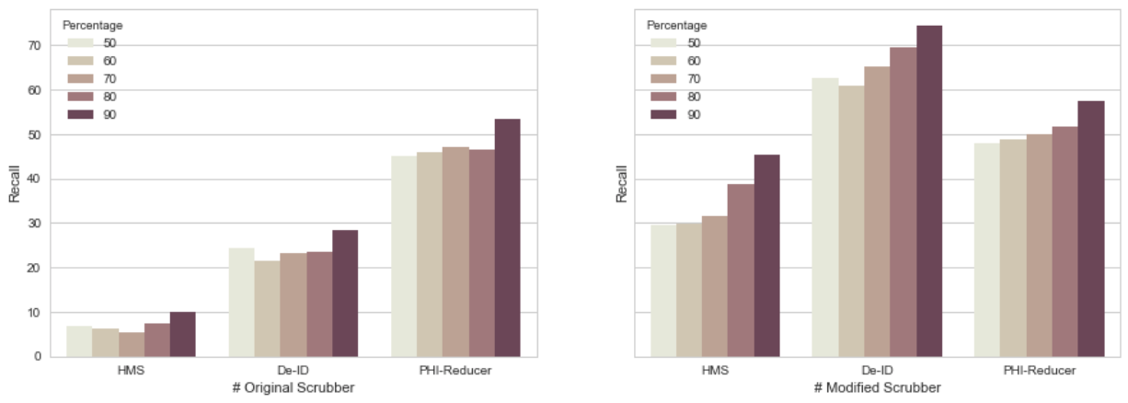

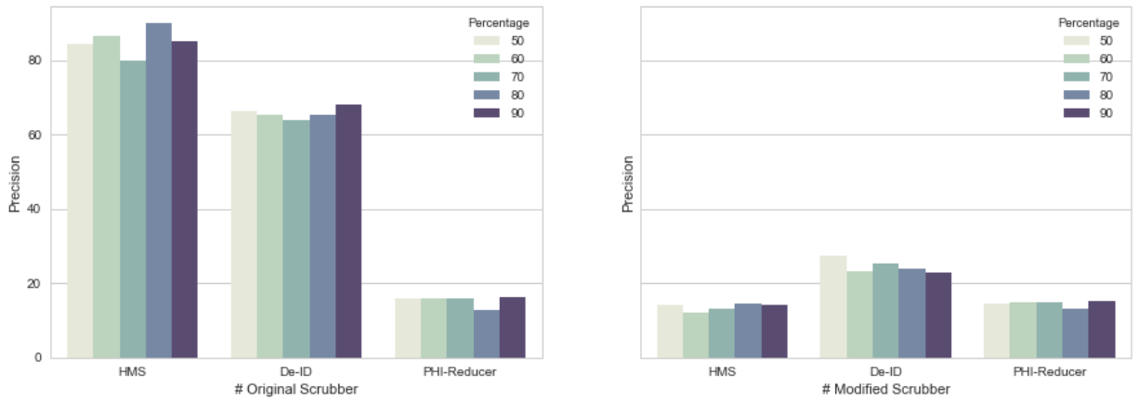

Figure 22. The comparison of Precision and Recall

on pattern matching based tools

Additionally, there are five different hybrid external dictionaries generated from five different training datasets, which is depicted as various colour in *Figure.22*. There is not much distinction in *Recall* side among them from diagrams to a particular original de-identification tool, but to the improved scrubbers, larger training size has a trend to get a relative higher *Recall*. Actually, the results it achieved is as expected. The reason why it looks like that is because the training datasets are just for training external dictionaries and have done nothing with original scrubbers, it will only have an impact on the improved scrubbers and the larger training dataset for establishing dictionary, the potential *PHI* tokens are more likely to be recognized and then the higher *Recalls* will get. But there are still some other objective reasons that would also have an effect on this result so as to generate some system errors. Such as, the error of the random sampling, the diversity of the using dataset … etc. But no matter what, the charts still show a clear tendency that three improved scrubbers get a relative low *Precision* after modification, but comparative high *Recall* and it turns higher with larger training dataset.

#### 3.1.1.2 Analysis on Machine Learning Based Scrubber

To the machine learning based scrubber, the analysis is in a different way. Also, because *MIST* is the only machine learning based tools used in this project, the performance analysis on *Precision and Recall* will be achieved in two ways ---- 1) comparing results between using original *MIST* training dataset and training dataset generated from the original i2b2 dataset. 2) comparing results with different number of training iteration in *MIST* on original i2b2 training dataset.

It is well-known that the training dataset plays a very important role in machine learning algorithms because they will learn features from the training dataset to build a recognize model. Besides, the number of training iteration is of great importance in machine learning algorithm as well, which can sensitively control the training model so that avoids the model becomes underfitting or overfitting. *Figure.23* is a series of curve graphs which describes the tendency of the *Recall and Precision* based on distinct training dataset differentiated by rows and different number of iterations separated by four different colour which are 5, 10, 15 and 20 times tested on *MIST*.

Firstly, from the first row, it is obviously that the performance on original *MIST* training dataset is very poor, whose highest *Recall and Precision* are 1.74% and 20% respectively. In contrast, the highest *Recall and Precision* tested on the generated training dataset are about 47% and 68% separately that are much larger than the previous test, meaning the feature model generated from *MIST* on original i2b2 dataset is much more suitable than using the default training dataset in *MIST* as expected. Moreover, it seems that the model trend to be overfitting when the number of iterations is around 15, because the distinction between 15 and 20 times is pretty small and the scrubbed number of *PHIs* turns to flatten out when the iteration is larger than 10. Detailed data are attached on the *Appendix.2.*

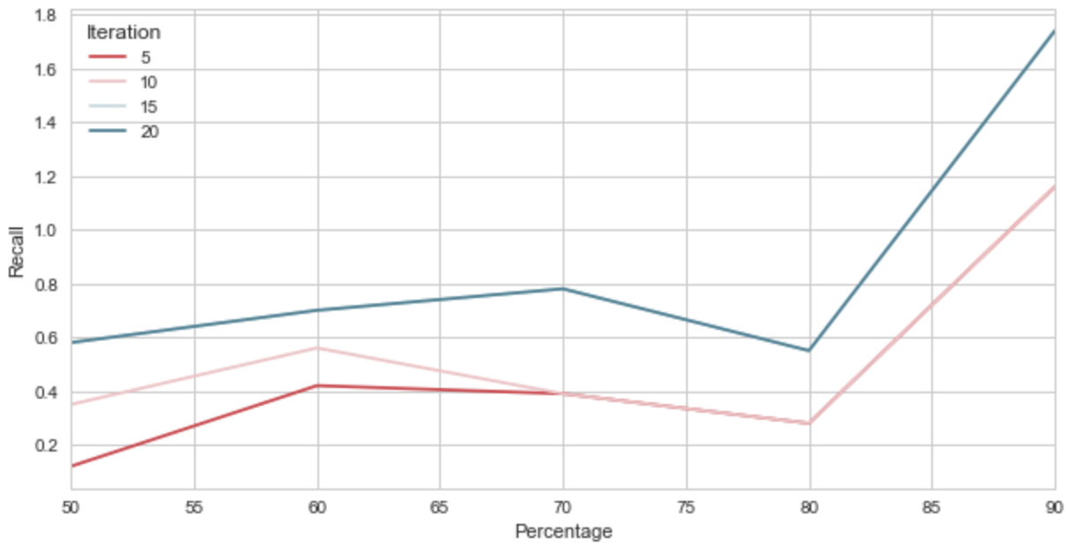 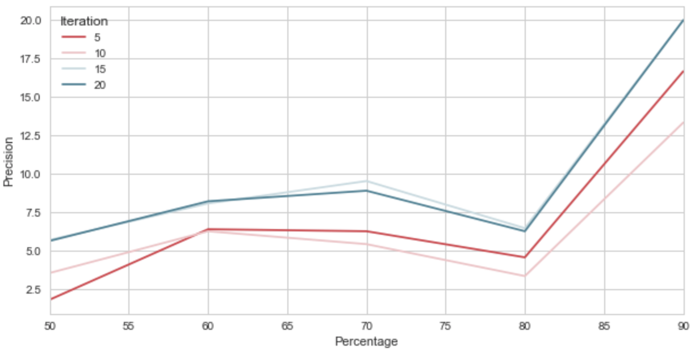

*(i) Test on the original MIST training dataset*

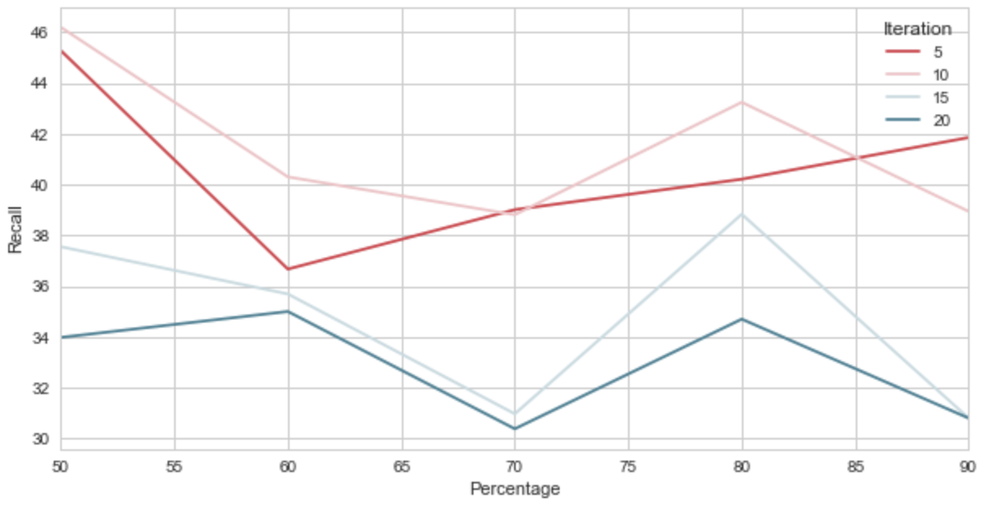 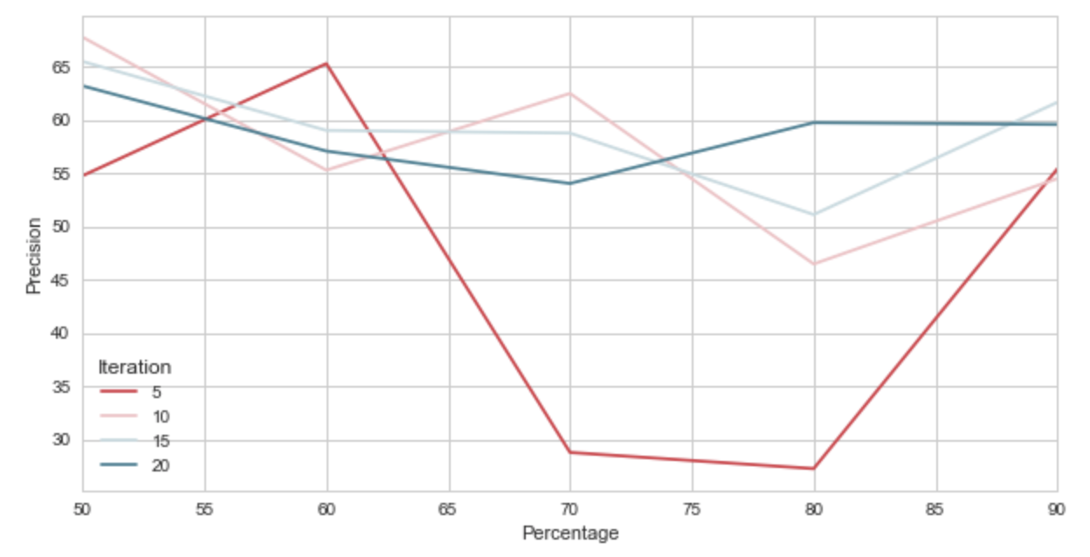

*(ii) Test on the training dataset generated from original i2b2 dataset*

Figure 23. The comparison of Precision and Recall

on MIST with different setting

Secondly, in the second row, the left chart represents the fluctuation of the *Recall and* the right one stands for the *Precision*. The highest *Precision* in *MIST* is67.74%, which is nearly 20% less than the best performance pattern matching based tool (90% from *HMS*). And the highest *Recall* is approximately 46.20%, which is about 30% lower than 74.42% in *DE-ID.* However, the highest *Precision and Recall* in *MIST* are both from the same iteration. It means that when the number of iteration is 10, *MIST* will give a relative high *Precision and Recall*, which seems more stable than pattern matching based tools that there is a large difference between the *Precision and Recall* and the highest *Precision and* *Recall* are from different de-identification scrubbers.

Additionally, it is clearly that when the number of iteration is 15 and 20, both of them achieve a relative high *Precision* but comparative low *Recall* from the diagrams. In this situation, the training model for de-identification can be regarded as becoming overfitting. On the contrary, it is apparent from the charts that when the number of iteration is 5, training model is considered as underfitting. Because the fluctuation of the red curve is much more dramatically than the other three curves and its *Precision* is lower than its *Recall* in a large range of percentage. In addition, as is demonstrated in the graphs, *Precision and Recall* are high enough when the training data is about 50%. It reveals one advantage of *MIST* that *PHI* terms’ features can be well-learned only on a relatively small training dataset, though the dataset need to be tagged and it is always done manually.

### 3.1.2 Different Dictionary Performance Comparison

In this part, a *‘Position’* and a *‘People’* external dictionary will be introduced respectively in turn in the following sub-sections. It is worth to noting that there is not distinction with people’s name and locations’ name in *PHI-Reducer* after scrubbing and machine learning based toolkit cannot directly use the imported external dictionary, so the analyses in this part are only based on *HMS and De-ID*. Additionally, as mentioned above, *‘Location’* and *‘Hospital’* categories are combined as *‘Position’* category and *‘Doctor’* and *‘Patient’* *PHI* categories are gathered as ‘*People’* category in this part.

#### 3.1.2.1 Only Import ‘Position’ Dictionary

According to *Figure.24*., the bar graphs show *Recall and Precision* on the original *HMS* and *De-ID* and their improved version (after importing *‘Position’* dictionary). More specifically, charts in the first row represent the change of *Recall*, in the second row stand for *Precision.* And the left two charts describe the test on original scrubbers and the right two diagrams depict the experiment on corresponding improved scrubbers.

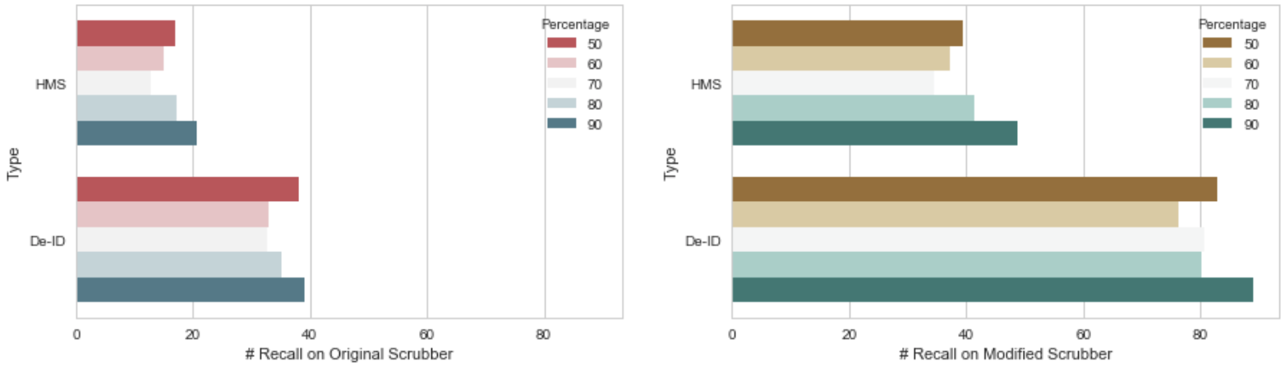

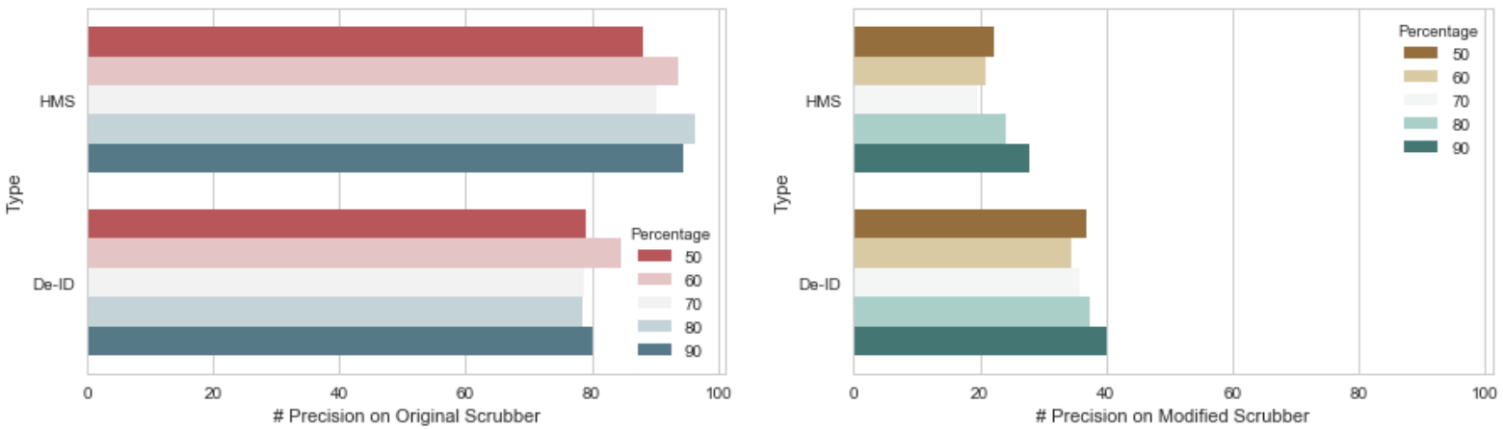

Figure 24. The comparison of Precision and Recall on

original HMS and De-ID with the scrubbers

after importing ‘Position’ Dictionary

As can be seen from graphs, before importing ‘*Position’* dictionary, *HMS* gets a relative lower *Recall* but a higher *Precision.* However, after importing external dictionary, *De-ID* performs better not only on *Precision* but on *Recall*. Moreover, although *Precision* on *De-ID* is reduced by a factor of about three, from approximately 50% decreasing to 18% on average, but *Recall* has grown about 3.6 times, increasing from 19% to 69% on average, which is very desirable. And *Recall* achieves about 60.23% when the training dataset is 50% of the original, representing that only small size of the training data can train a reasonable good *‘Position’* dictionary based on original i2b2 dataset.

Furthermore, to both of the scrubbers, there is a considerable increase occurring on *Recall*, but an inverse tendency occurring on *Precision*. It means that the external ‘*Position’* dictionary really do help on the de-identification tools for finding *PHI* terms at the cost of some extent of *Precision,* but high *Recall* is much more desired in this project because of the possibility of protecting more patients’ privacy information. Namely, the external *’Position’* dictionary can really improve scrubbers to retrieve more *‘Hospital’ and ‘Location’ PHI* tokens in the clinical narratives so as to de-identify more of them.

#### 3.1.2.2 Only Import ‘People’ Dictionary

Although the way for using the training ‘*People’* external dictionary and the procedures processing on de-identification is very similar to ‘*Position’* dictionary, ‘*People’* dictionary’s behaviour on scrubbing is shown in a completely different way as depicted in *Figure.25*.

Surprisingly, both *HMS Scrubber* and *De-ID Scrubber* do badly in scrubbing people’s name. As is shown in the diagrams, the original *HMS Scrubber* can hardly de-identify a name on the test dataset, which makes both of the *Recall and Precision* become 0. And although the original *De-ID Scrubber* performs a better than *HMS Scrubber,* the average of *Recall* is still only about 15.63%. However, the good news is that the value of *Recall* is effectively increased on both modified scrubber (importing *‘People’* dictionary). The average of *Recall* on *HMS Scrubber* is from 0% to 31.03% and 15.63% to 55.91% on *De-ID Scrubber*. Apparently, on the one hand, *De-ID Scrubber* achieves a considerable good enough *Recall*, whose highest value is about 64%. On the other hand, the performance of *HMS Scrubber* is much more satisfied than before, which obtains about 42% and 11% for the highest *Recall and Precision* separately and it has a stable tendency that it will attain a higher *Recall* with larger training dataset.

However, it is worth noting that both of the scrubbers imported *‘People’* dictionary still performs much worse than imported *‘Position’* dictionary, whose highest *Recall* are 64% and 89% respectively. There are many causes for this phenomena that people’s names seem to be poorly recognized by both of the scrubbers. In this case, after observing original dataset, an inferred reason could be the diversity of people’s name. One aspect is that pattern matching based scrubbers always use regular expression for identifying name patter, but people’s names are different a lot in different regions. And to be honest, it is still very difficult for a professional programmer to write a series of comprehensive *RegExps* that can completely describe all kind of names. For example, *HMS* already has many *RegExps* for identifying doctor’s name, but there are still many situations not considered. Another aspect is that sometimes scrubbers use some indicators for identifying the possible *PHIs*. For instance, ‘street’, ‘road’ … etc. words are as indicators to *‘Location’* category. But there is not much word can be taken as an indicator to a *‘Name’* category. Therefore, the overall performance of *‘People’* dictionary is poorer than *‘Position’* dictionary.

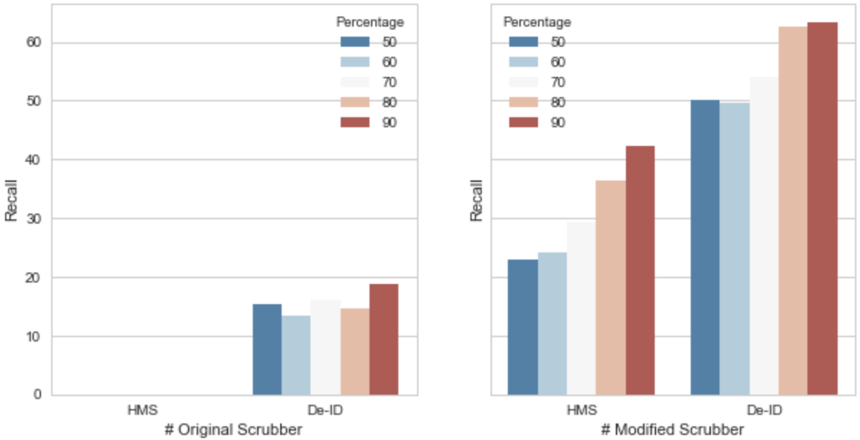

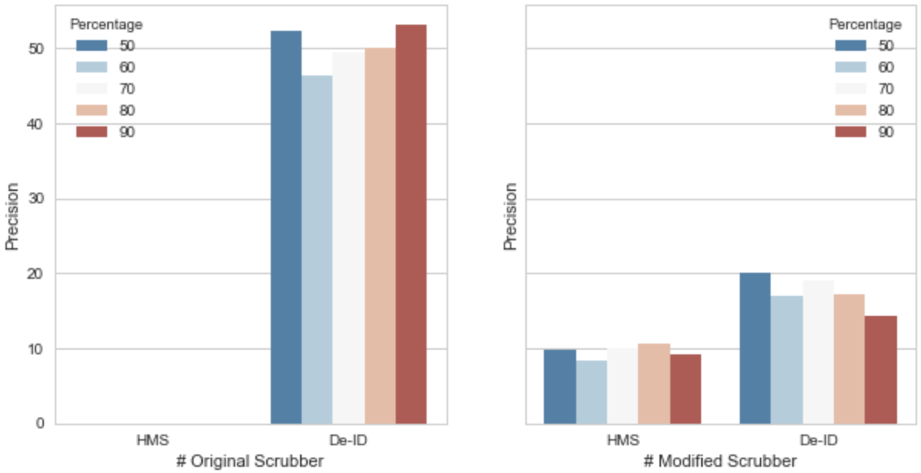

Figure 25. The comparison of Precision and Recall on

original HMS and De-ID with the scrubbers

after importing ‘People’ dictionary

### 3.1.3 Variation of De-identification Tool

There are two different variation of scrubbers based on original *HMS* and *De-ID* will be shown in this section. After observing the experiment results, it is noteworthy that the scrubbing performance on single external dictionary is different from on both ‘*Position’ and ‘People’* dictionaries. Thus, analyses in this section will consider these as different situations and separately discuss on them. Brief illustration of these variations of scrubbers are shown as below:

* ***Analysis on Mixed Scrubber***: In this part, *HMS* and *De-ID* are combined together, aiming to achieve a better de-identification performance. In other words, a “new” scrubber is established by adding people’s name part from *HMS* into *De-ID* so as to see if a better performance of scrubbing will be generated. It will be separated into two portions --- 1) Import default name dictionary from the *HMS* and 2) Import the default *RegExps* from *HMS*.
* ***Analysis on Only Importing Training Dictionary:*** Another analysis wants to show the performances on *HMS and De-ID* by only using the training external dictionaries. In other words, it will remove all of the default dictionaries and libraries built in the scrubbers themselves so that to evaluate whether a training dictionary is enough or not for de-identification. This portion will be divided into three parts --- 1) only use *‘People’* dictionary, 2) only use *‘Position’* dictionary and 3) only use both *‘People’* and *‘Position’* dictionaries.

#### 3.1.3.1 Mixed De-identification Tool

For the sake of obtaining a better de-identification tool, the advantages of both scrubber will be combined in this part and because *Recall* is the most concerned value in this project, only *Recall* will be depicted in this part and more complete data can be seen from the *Appendix 5*.

After observing, the original *De-ID* has a much more comprehensive *‘Position’* dictionaries than *HMS,* but there is no *RegExp* matching in *De-ID* and the default name dictionaries in *De-ID* are not as complete as in *HMS* as well. Therefore, a guess occurs, which is that if *De-ID* can be improved by importing the default name dictionary and *RegExps* for people’s name from *HMS*.

*Table.1*. represents the situation when *De-ID* only uses the training ‘*People’* dictionary but *‘Position’* dictionary. There is no doubt that *Recall* on *De-ID* has been improved after importing the name dictionary and *RegExp* matching from the *HMS*.

Table 1. Original De-ID and improved De-ID

(only 'People' dictionary imported)

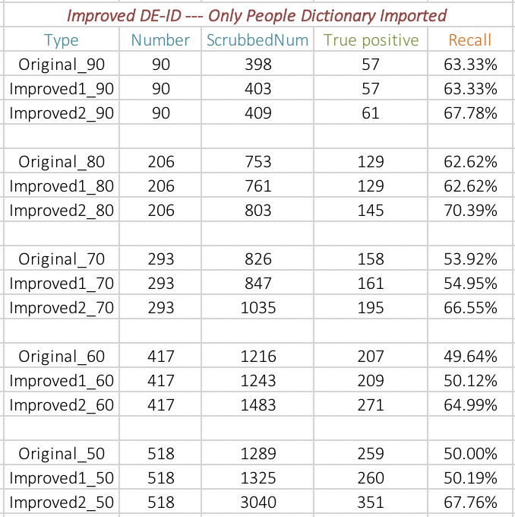

*Note: Original_* --- Original De-ID*

*Improved1_* --- Imported name dictionary into De-ID*

*Improved2_* --- Imported name dictionary and RegExp into De-ID*

*90/80/70/60/50 --- Means the training dataset is how much percent of the original dataset*

Obviously, there is no big distinction on *Recall* when only importing name dictionary into *De-ID*, especially when the size of training dataset is more than 80%, meaning that the training *‘People’* dictionary is good enough when the training dataset is big enough. Additionally, an obvious increase occurs after importing *RegExps* into *De-ID*. It makes the average of *Recall* become about 68%, although there isa relative large fluctuation among various sizes of the training dataset. *Table.1* also shows that, *Recall* generated from 50% training dataset is pretty close to that generated from 90% training dataset, indicating that a comparative small training dataset can also perform scrubbing well on the improved *De-ID.* Furthermore, as mentioned before, a scrubber will perform different between importing a single external dictionary with importing multiple external dictionaries. Therefore, for the sake of observing the results of importing multiple external dictionaries, an experiment is created on importing both ‘*People’ and ‘Position’* dictionaries and the results are shown in *Table.2*.

Table 2. Original De-ID and Improved De-ID

(Both ‘People’ and ‘Position’ dictionary imported)

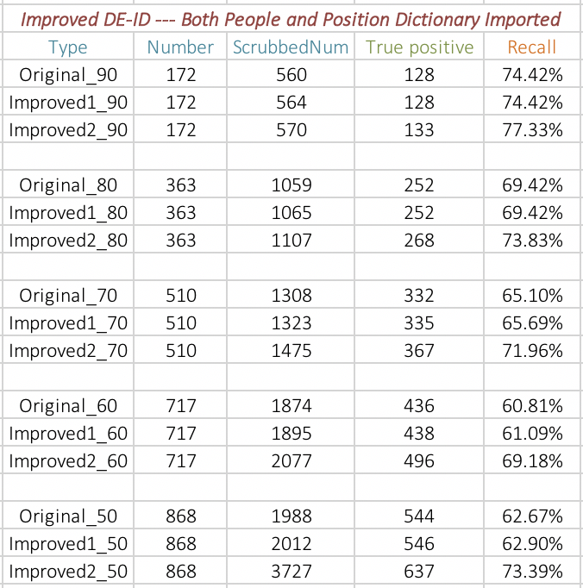

From *Table.2.,* the tendency of *Recall* is very similar to *Table.1*., but the overall *Recall* is much higher than *Table.1*. Moreover, the highest *Recall* in *Table.2*. is 77.33%, which is when the training dataset is 90% of original and both name dictionary and *RegExps* are imported into *De-ID* from *HMS*, and the average of *Recall* in the final improved *De-ID* is approximately 73.14%. It is much larger than the average of *Recall* in the original *HMS and De-ID*, which is 35.02% and 66.48% respectively from the data in *Appendix.1*. This result is very inspired, because it means that *De-ID* is really improved by adding some elements from *HMS*.

#### 3.1.3.2 Only Use Training Dictionary

In order to evaluate the ability of external dictionary, a special test is created in this part that plans to remove all of the default libraries and dictionaries in the de-identification tools and just scrub the clinical narratives by using the external training dictionary. A series analyses on ‘only use external training dictionary’ by using *HMS and De-ID* are shown in *Table.3*., whose left and right table represent the results on *HMS* and *De-ID separately*. The basic operations in this section are ---- 1) Test on only importing *‘People’* dictionary, 2) Test on only importing *‘Position’* dictionary and 3) Test on only importing both *‘People’* and *‘Position’* dictionaries. In this way, the effect of a single external dictionary and the combination of external dictionaries on the scrubbers can be obviously shown.

Firstly, to *HMS*, it is apparently that almost all of the identified people’s name *PHIs* are scrubbed by the training *‘People’* dictionary because *Recall* from ‘*Dictionary_People’* is nearly the same as *‘Only_Import_People’. ‘Dictionary_People’* means that original scrubber is improved by adding the training *‘People’* dictionary and *‘Only_Import_People’* represents that modifies original scrubber by removing all of the default dictionaries and just using the training *‘People’* dictionary. Furthermore, the majority of the number of scrubbed *PHIs* and the number of correct scrubbed *PHIs* from *‘Dictionary_People’* are more than *‘Only_Import_People’* on *HMS*, it seems that only using *‘People’* dictionary on *HMS* performs better than adding it into the original scrubber and let it work with some default libraries that are inside the scrubber. However, *‘Position’* dictionary behaves in a relative inverse way of this respect on *HMS*. Although the performance of *‘Dictionary_Position’ and ‘Only_Import_Position’* are almost the same, *‘Dictionary_Position’* still achieve a little bit higher than ‘*Only_Import_Position’* in the number of scrubbed *PHIs* and the number of correct scrubbed *PHI*s. And this tendency is pretty similar to the overall performance *(‘Dictionary_Total’ and ‘Only_Import_Total’*).

Table 3. Only use training dictionary on HMS and De-ID

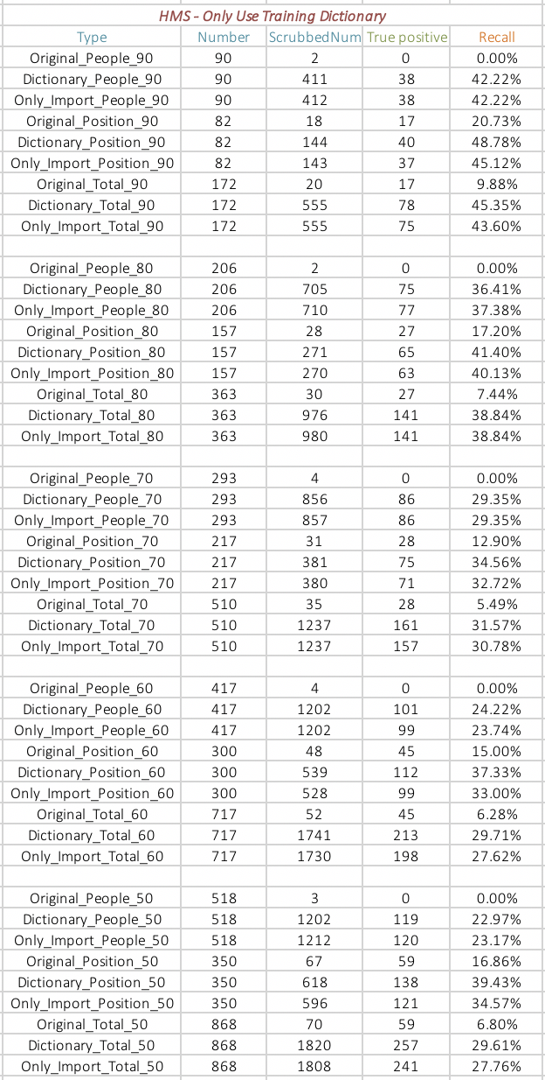 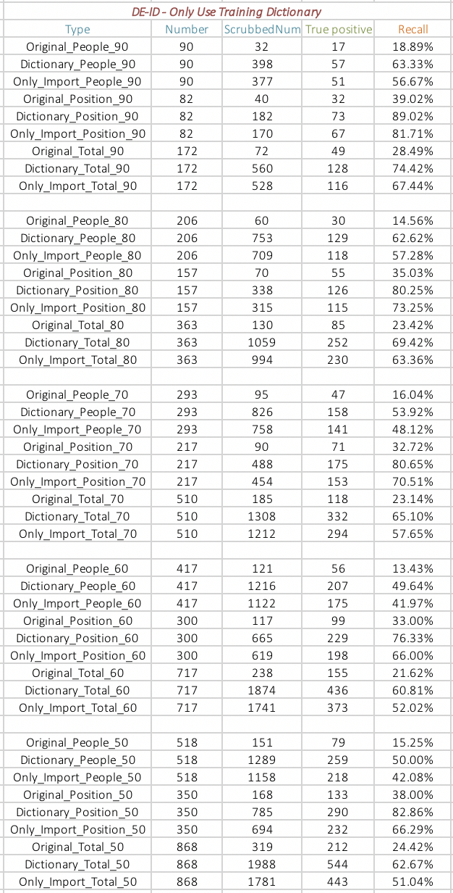

*Note:* *Original_People_* --- Original Scrubber for scrubbing people’s name*

*Dictionary_People_* --- Original Scrubber + ‘People’ external dictionary for scrubbing people’s name*

*Only_Import_People_* --- Only imported ‘People’ external dictionary into original scrubber*

*Original_Position_* --- Original Scrubber for scrubbing position*

*Dictionary_Position_* --- Original Scrubber + ‘Position’ external for scrubbing position*

*Only_Import_Position_* --- Only imported ‘Position’ external dictionary into original Scrubber*

*Original_Total_* --- Original Scrubber for scrubbing people’s name and position*

*Dictionary_Total_* --- Original Scrubber + ‘People’ and ‘Position’ external dictionary for scrubbing*

*Only_Import_Total_* --- Imported both ‘People’ and ‘Position’ external dictionary into original Scrubber*

*90/80/70/60/50 --- Means the training dataset is how much percent of the original dataset*

Then, to *De-ID*, the *‘Only_Import_Total’* trend is like *HMS* that nearly all of the scrubbed *PHIs* are scrubbed by the external training dictionaries. However, there is a little bit difference is that the recognition capability of the built-in dictionaries from original *De-ID* are better than *HMS* in both *‘People’ and ‘Position’* aspect, because *Recall* from *‘Dictionary_People’ and ‘Dictionary_Position’* categories are bigger than *‘Only_Import_People’ and ‘Only_Import_Position’* classes *on De-ID*. Actually, the performance of *‘Only_Import_Total’ on De-ID* is desirable, because the highest *Recall* can achieve 67.44%, which is not that bad comparing to *‘Dictionary_Total’* that is 74.42%.

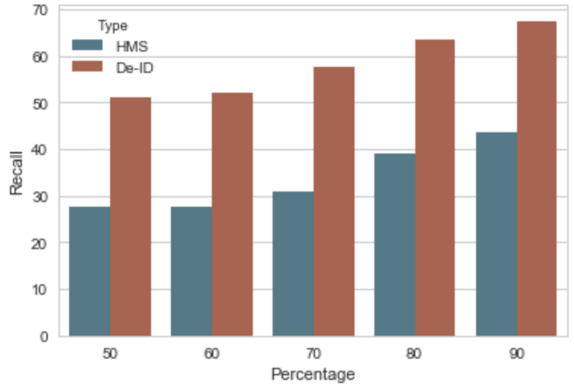

Figure 26. The comparison between HMS and De-ID on 'Only_Import_Total'

In addition, the overall *Recall* on *De-ID* is much better than on *HMS* as described in *Figure.26,* whose average *Recall* is about 58.31% and 33.72% respectively. Also, there is a tendency that *Recall* turns larger with the increasing size of the training dataset, which is because *PHI* tokens are more likely to be selected into the external dictionary when the training dataset becomes bigger.

## 3.2 Colander Approach Analysis

# 4 Conclusion

# Reference

[1] Murphy, J.W., Choi, J.M., & Cadeiras, M. (2016). The Role of Clinical Records in Narrative Medicine: A Discourse of Message. *The Permanente Journal,* 20(2), 103-108. doi:10.7812/TPP15-101.

[2] Ferrández, O., South, B., Shen, S., Friedlin, F., Samore, M., & Meystre, S. (2013). BoB, a best-of-breed automated text de-identification system for VHA clinical documents. *Journal Of The American Medical Informatics Association*, *20*(1), 77-83. doi:10.1136/amiajnl-2012-001020.

[3] Meystre, S. M., Friedlin, F. J., South, B. R., Shen, S., & Samore, M. H. (2010). Automatic de-identification of textual documents in the electronic health record: a review of recent research. *BMC Medical Research Methodology*, *10*70. doi:10.1186/1471-2288-10-70.

[4] Ferrandez, O., South, B. R., Shen, S., Samore, M. H., Meystre, S. M., & Friedlin, F. J. (n.d). Evaluating current automatic de-identification methods with Veteran's health administration clinical documents. *Bmc Medical Research Methodology*, *12.*

[5] Mist-deid.sourceforge.net (n.d.). MIST: The MITRE Identification Scrubber Toolkit. AMIA TASK [online] Available at: <http://mist-deid.sourceforge.net/current_docs/html/index.html> [Accessed 30 Mar, 2018]

[6] i2b2: The Intergrating Biology and the Bedside organization. (2005). [online] Available at: <https://www.i2b2.org/NLP/DataSets/Main.php> [Accessed 31 Mar,2018]

[7] Stubbs, A., & Uzuner, O. (2015). Annoatating longitudinal clnical narratives for de-identification: The 2014 i2b2/UTHealth corpus. *Journal Of Biomedical Informatics*, S20-S29. Doi:10.1016/j.jbi.2015.07.020.

[8] Beckwith, B.A., Mahaadevan, R. Bails, U.J., & Kuo, F. (2006). Development and evaluation of an open source software tool for deidentification of pathology reports, *BMC Medical Informatics & Decision Making*, 6(1), 12-10. Doi:10.1186/1472-6947-6-12.

[9] Gupta, D., Saul, M., & Gilbertson, J. (2004). Evaluation of a Deidentification (De-Id) Software Engine to Share Pathology Reports and Clinical Documents for Research. *AMERICAN JOURNAL OF CLINICAL PATHOLOGY*, (2). 176.

[10] Aberdeen, J., Bayer, S., Yeniterzi, R., Wellner, B., Clark, C., Hanauer, D., & … Hirschman, L. (2010). The MITRE Identification Scrubber Toolkit: Design, training, and assessment. *International Journal Of Medical Informatics*, 79, 849-859. doi:10.1016/j.ijmedinf.2010.09.007.

# Appendix

Experiment Analysis Data

1. Analysis Data for section 3.1.1.1:

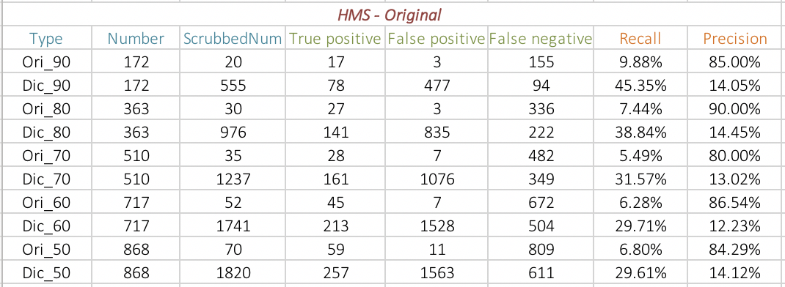

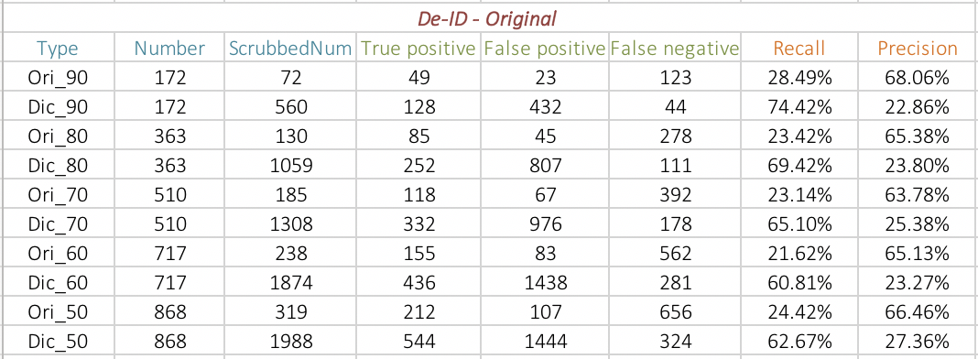

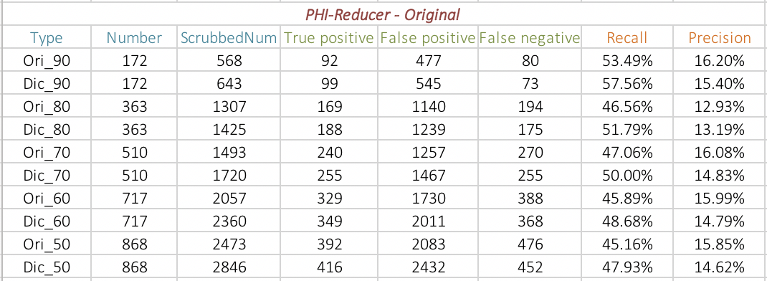

The Total Analysis among

The Pattern Matching Based Scrubber Tools

2. Analysis Data for section 3.1.1.2:

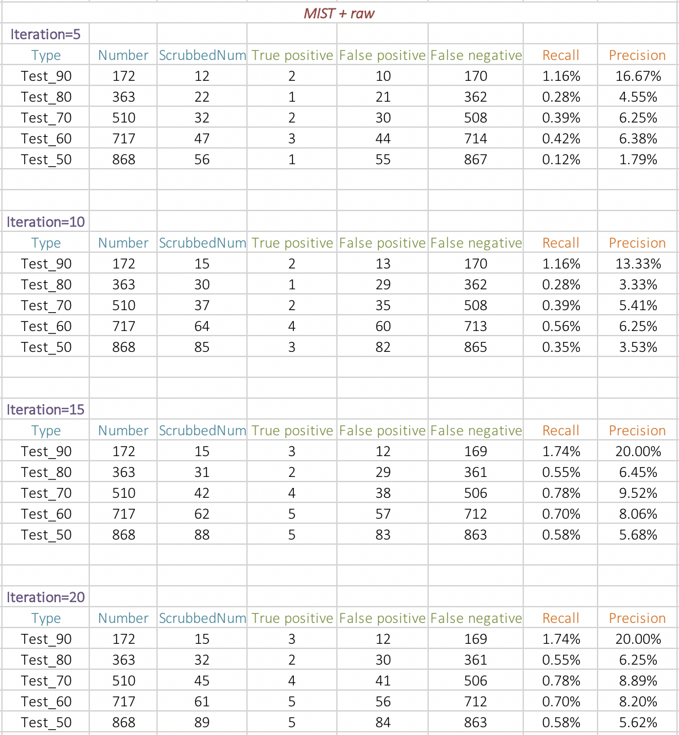

*(i) Test on the original MIST training dataset*

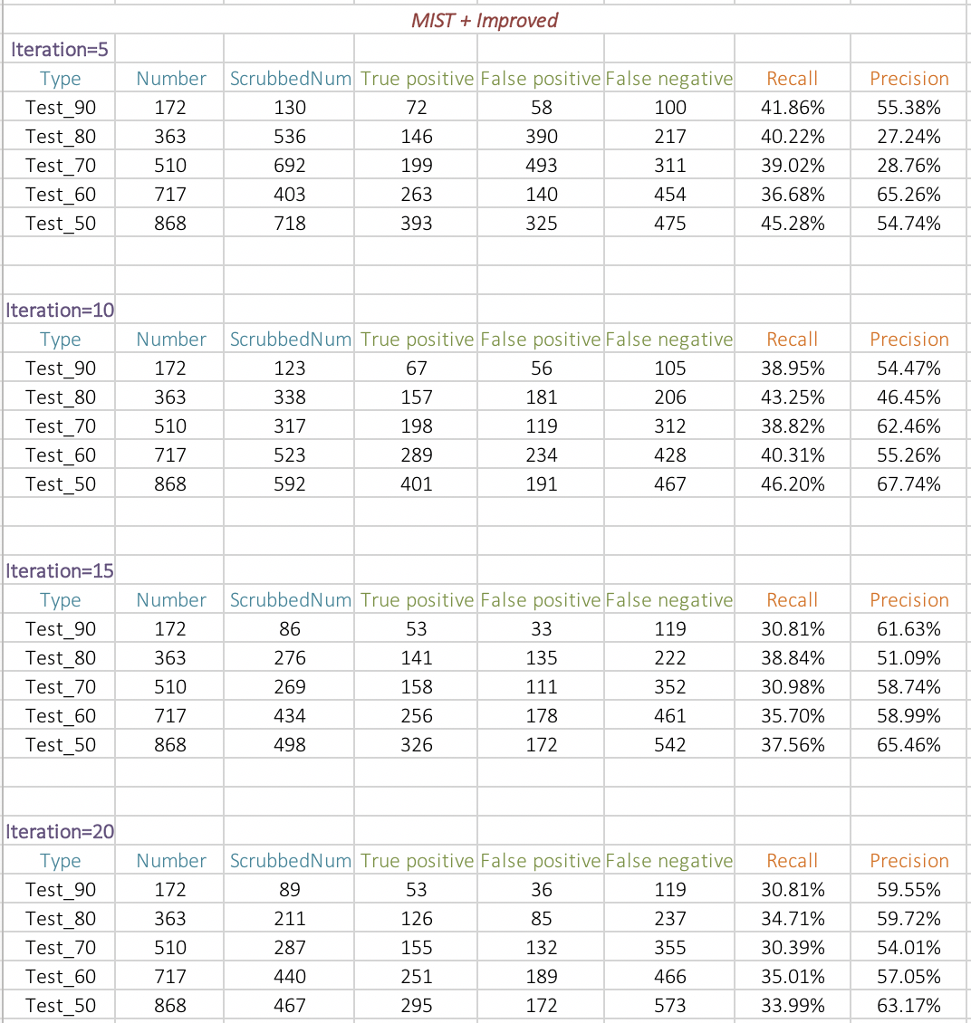

*(ii) Test on the generated training dataset*

The Total Analysis among

The Machine Learning Based Scrubber Tools

3. Analysis Data for section 3.1.2.1:

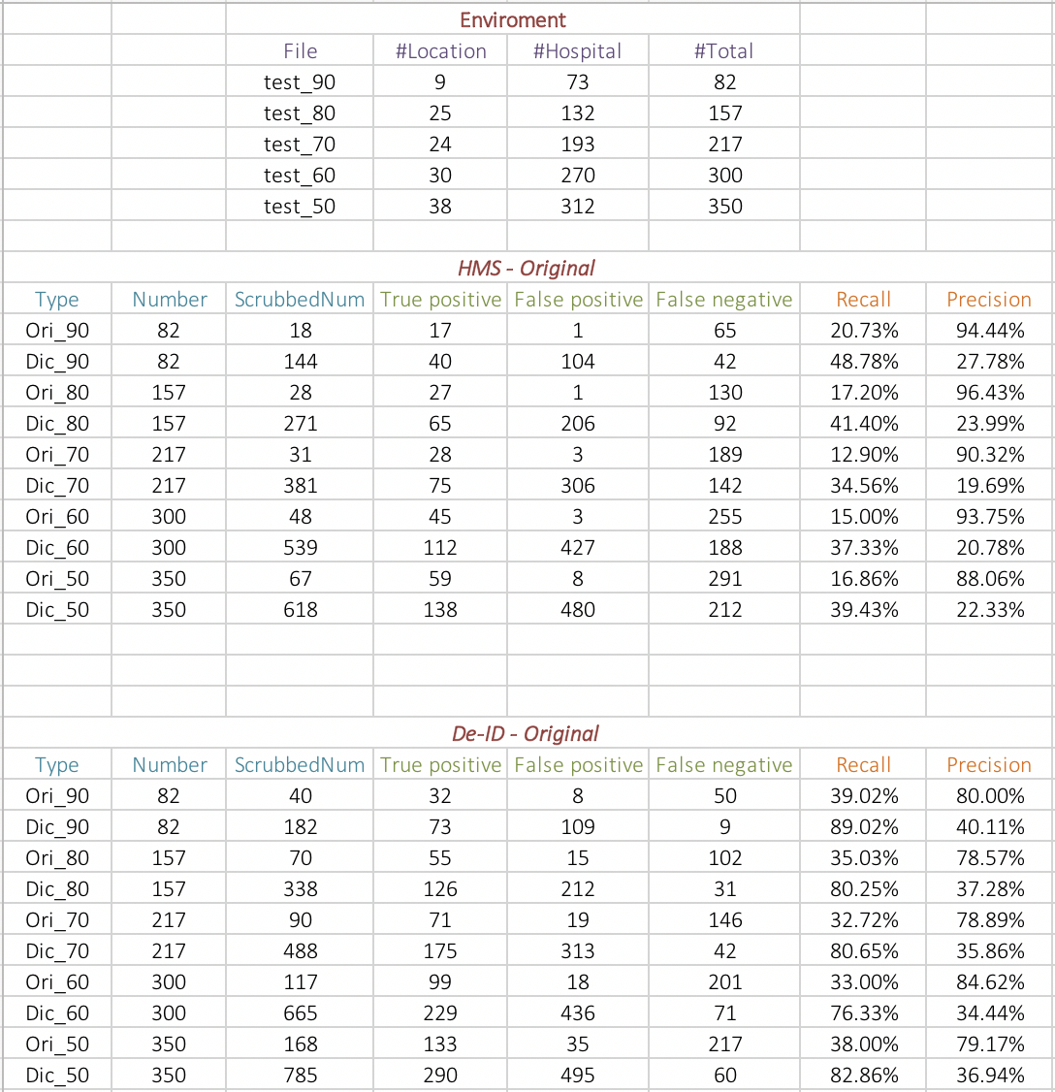

*Note: Position = Location + Hospital*

4. Analysis Data for section 3.1.2.2:

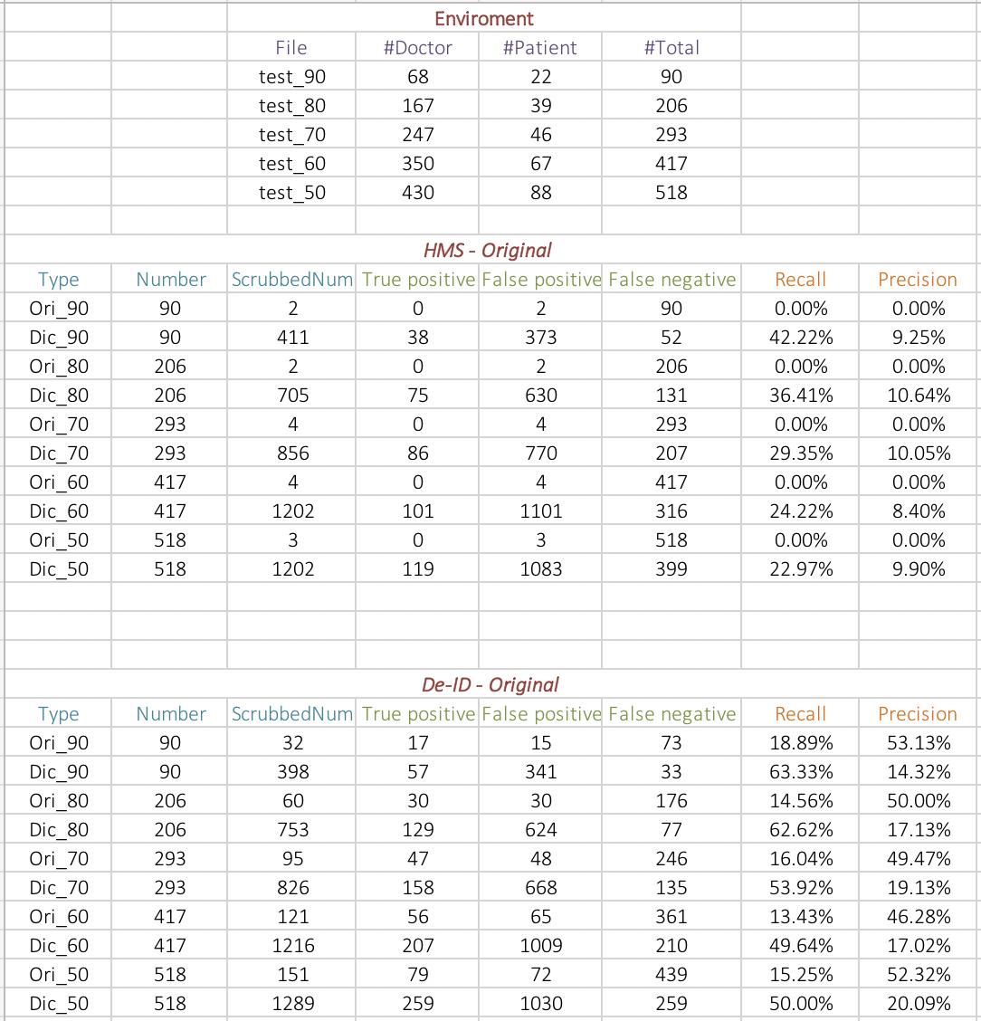

*Note: People = Doctor + Patient*

5. Analysis Data for section 3.1.3.1:

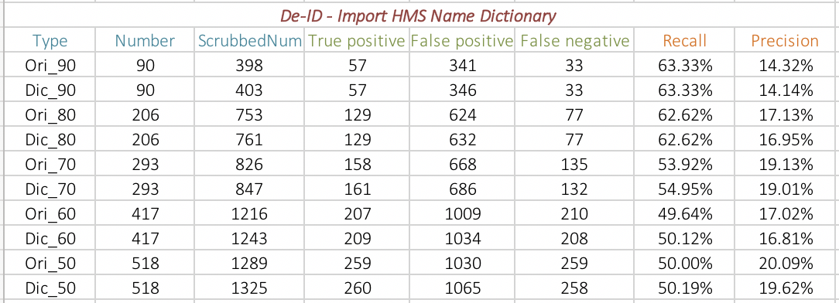

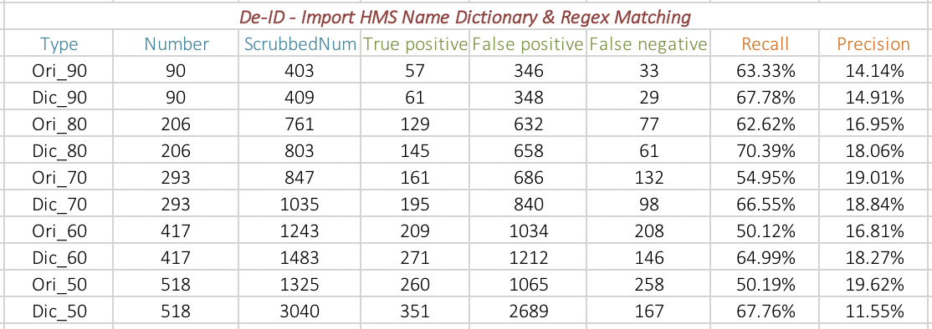

*(i) The People Dictionary Analysis (only import People dictionary)*

*for the Mixed Scrubber*

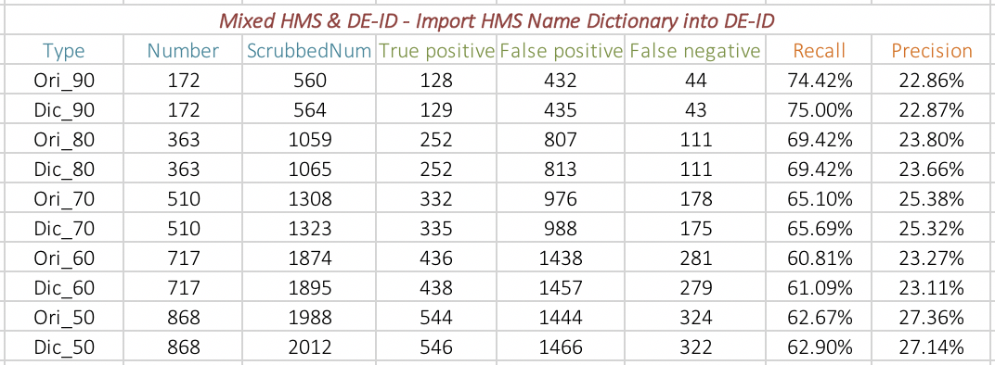

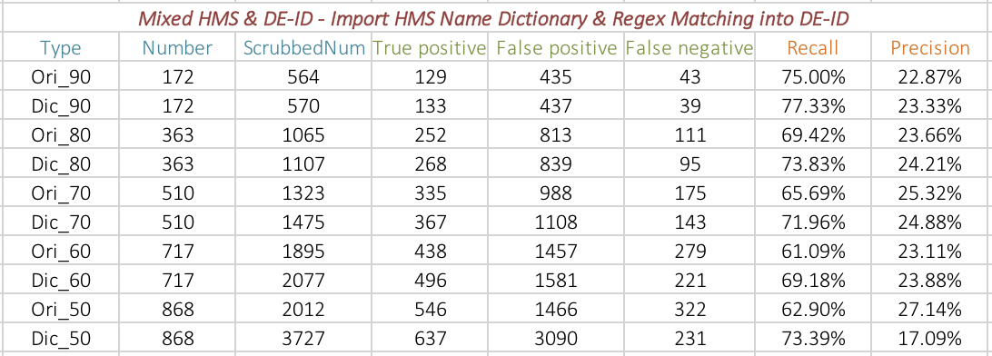

*(ii) The Total Analysis (import People and Position dictionary)*

*for the Mixed Scrubber*

6. Analysis Data for section 3.1.3.2:

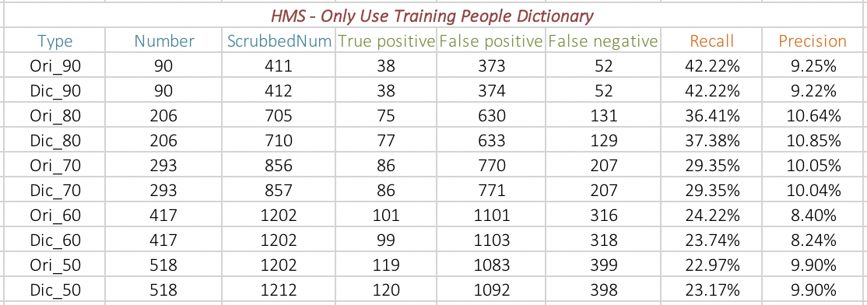

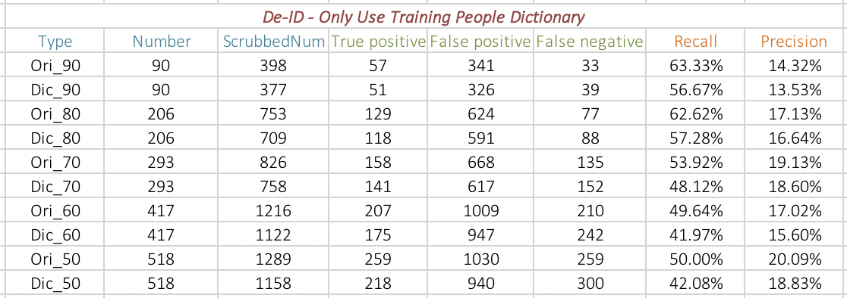

*(i) Only Importing ‘People’ External Dictionary*

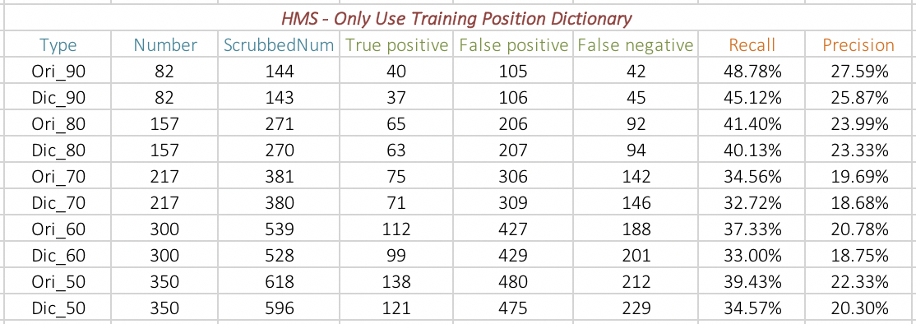

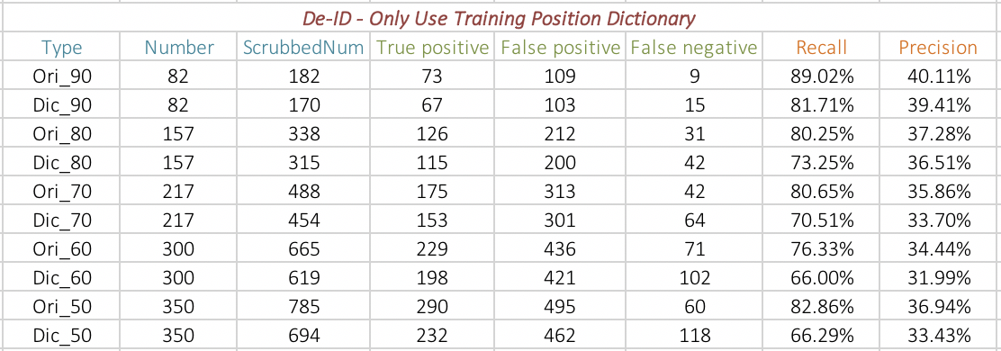

*(ii) Only Importing ‘Position’ External Dictionary*

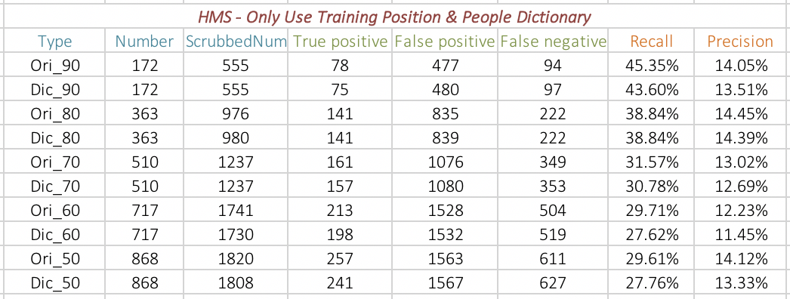

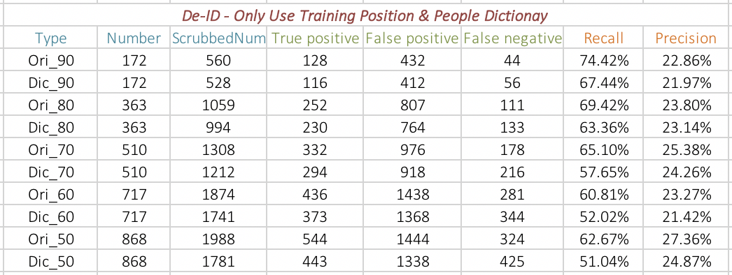

*(iii) Only Importing Both ‘People’ and ‘Position’ Dictionaries*